Landforms

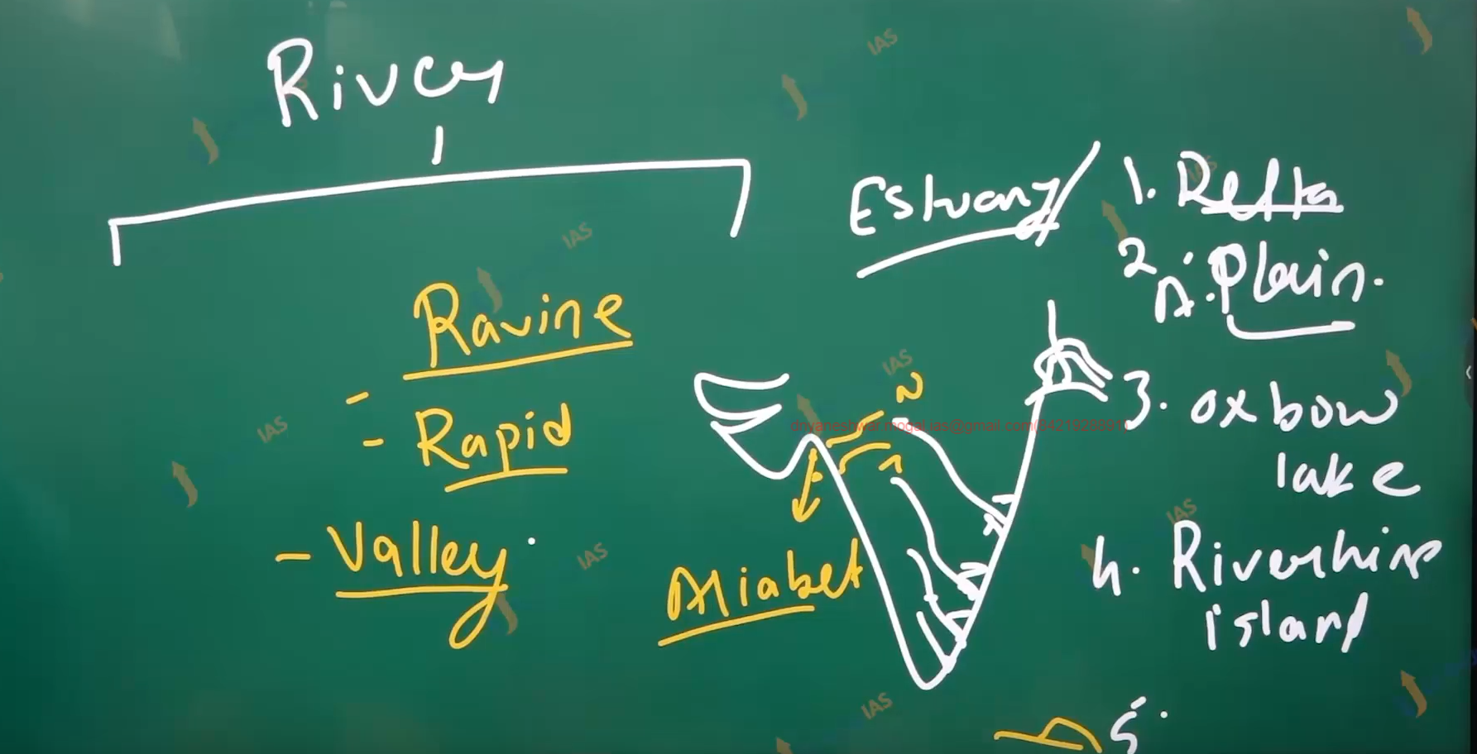

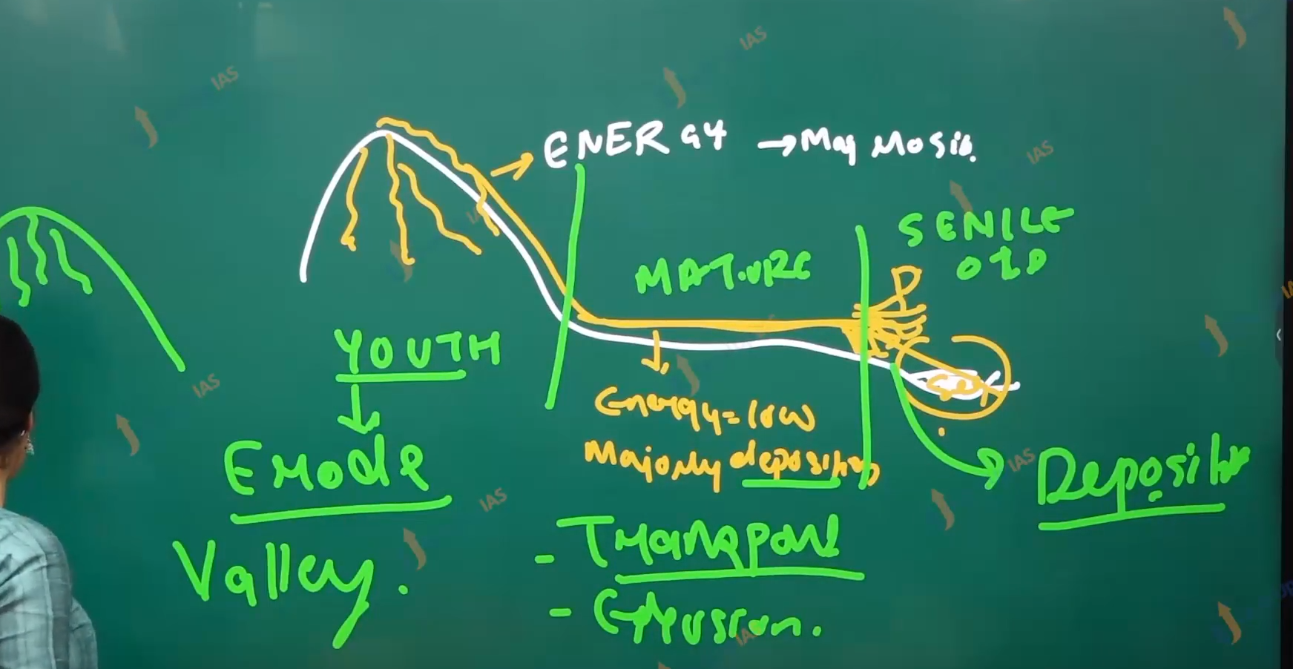

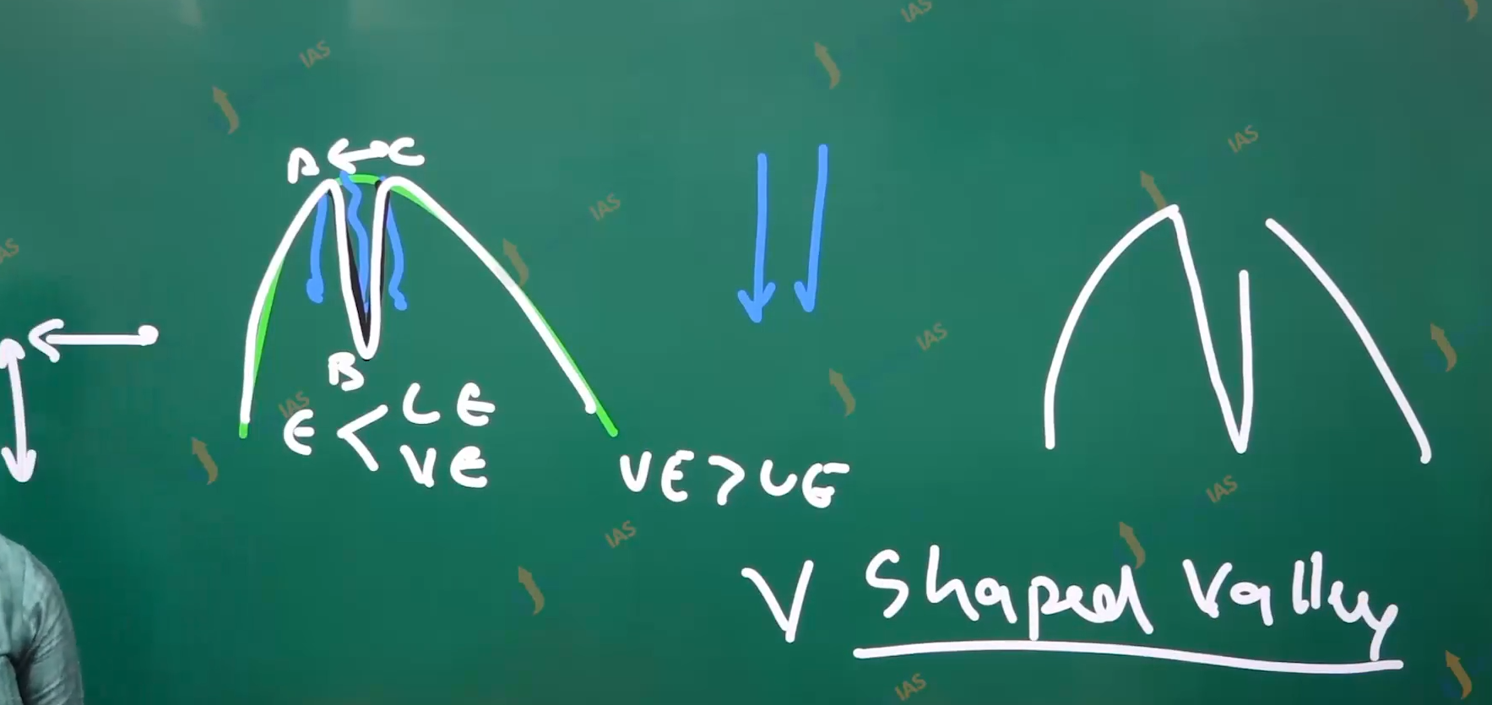

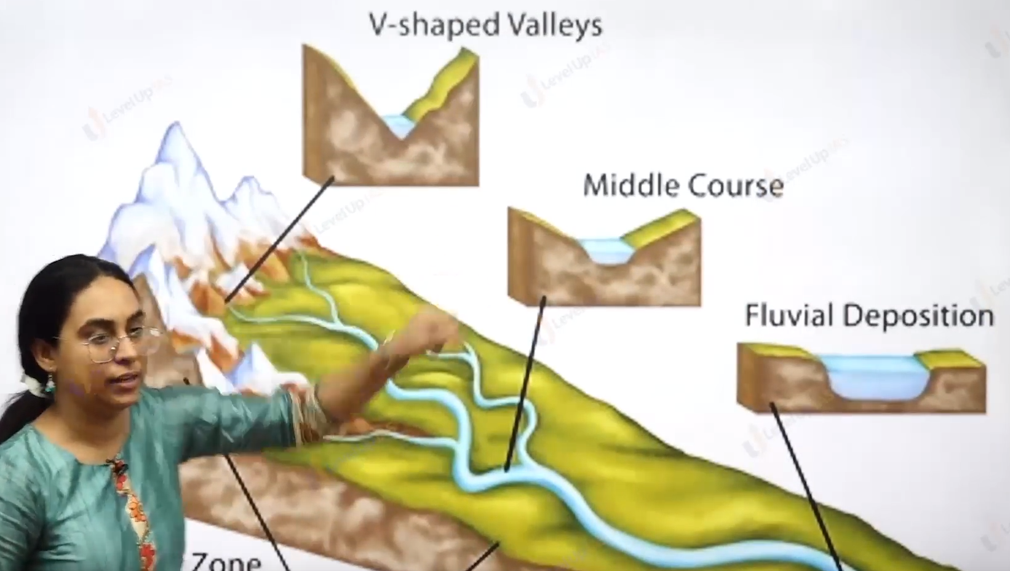

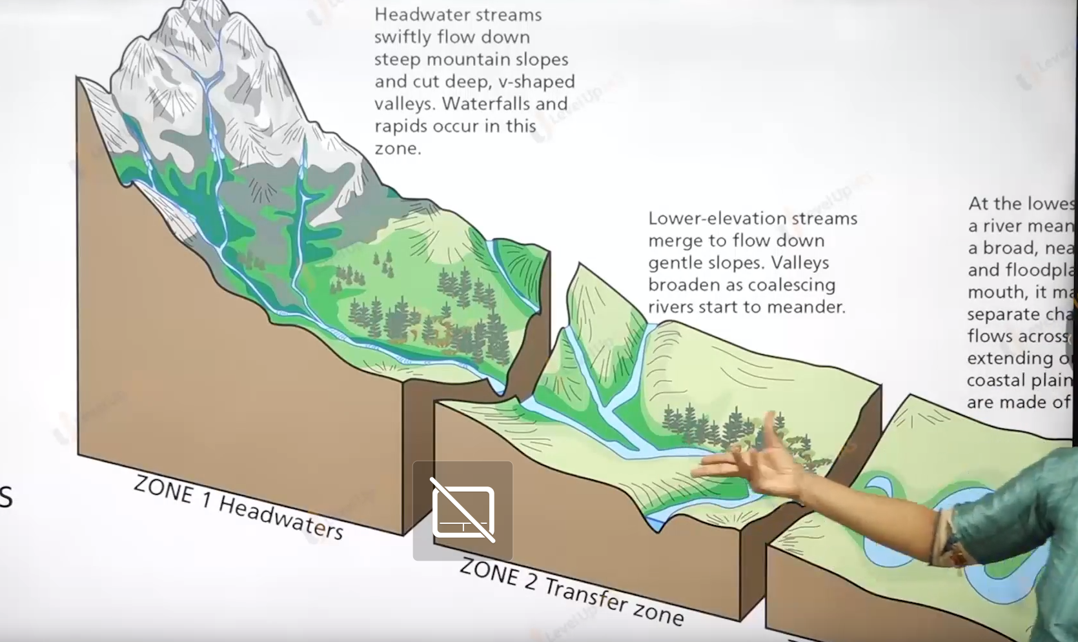

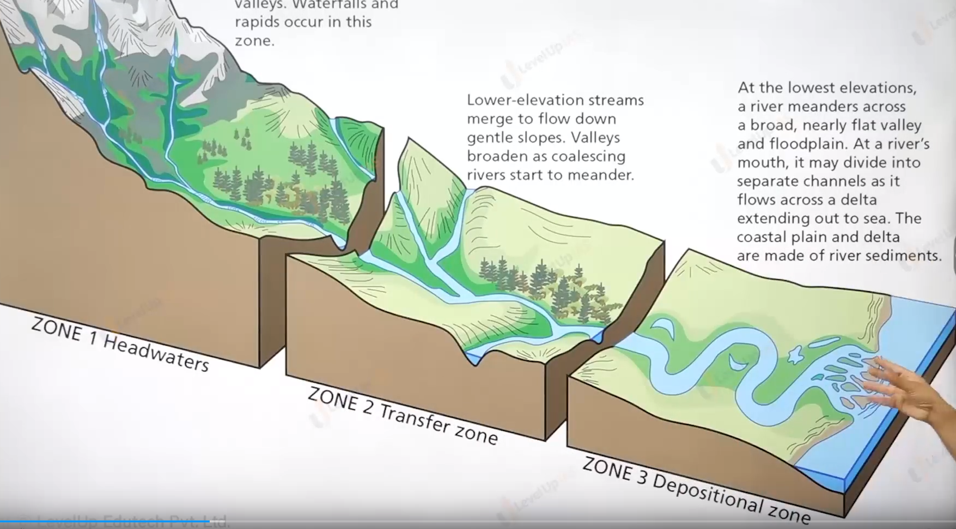

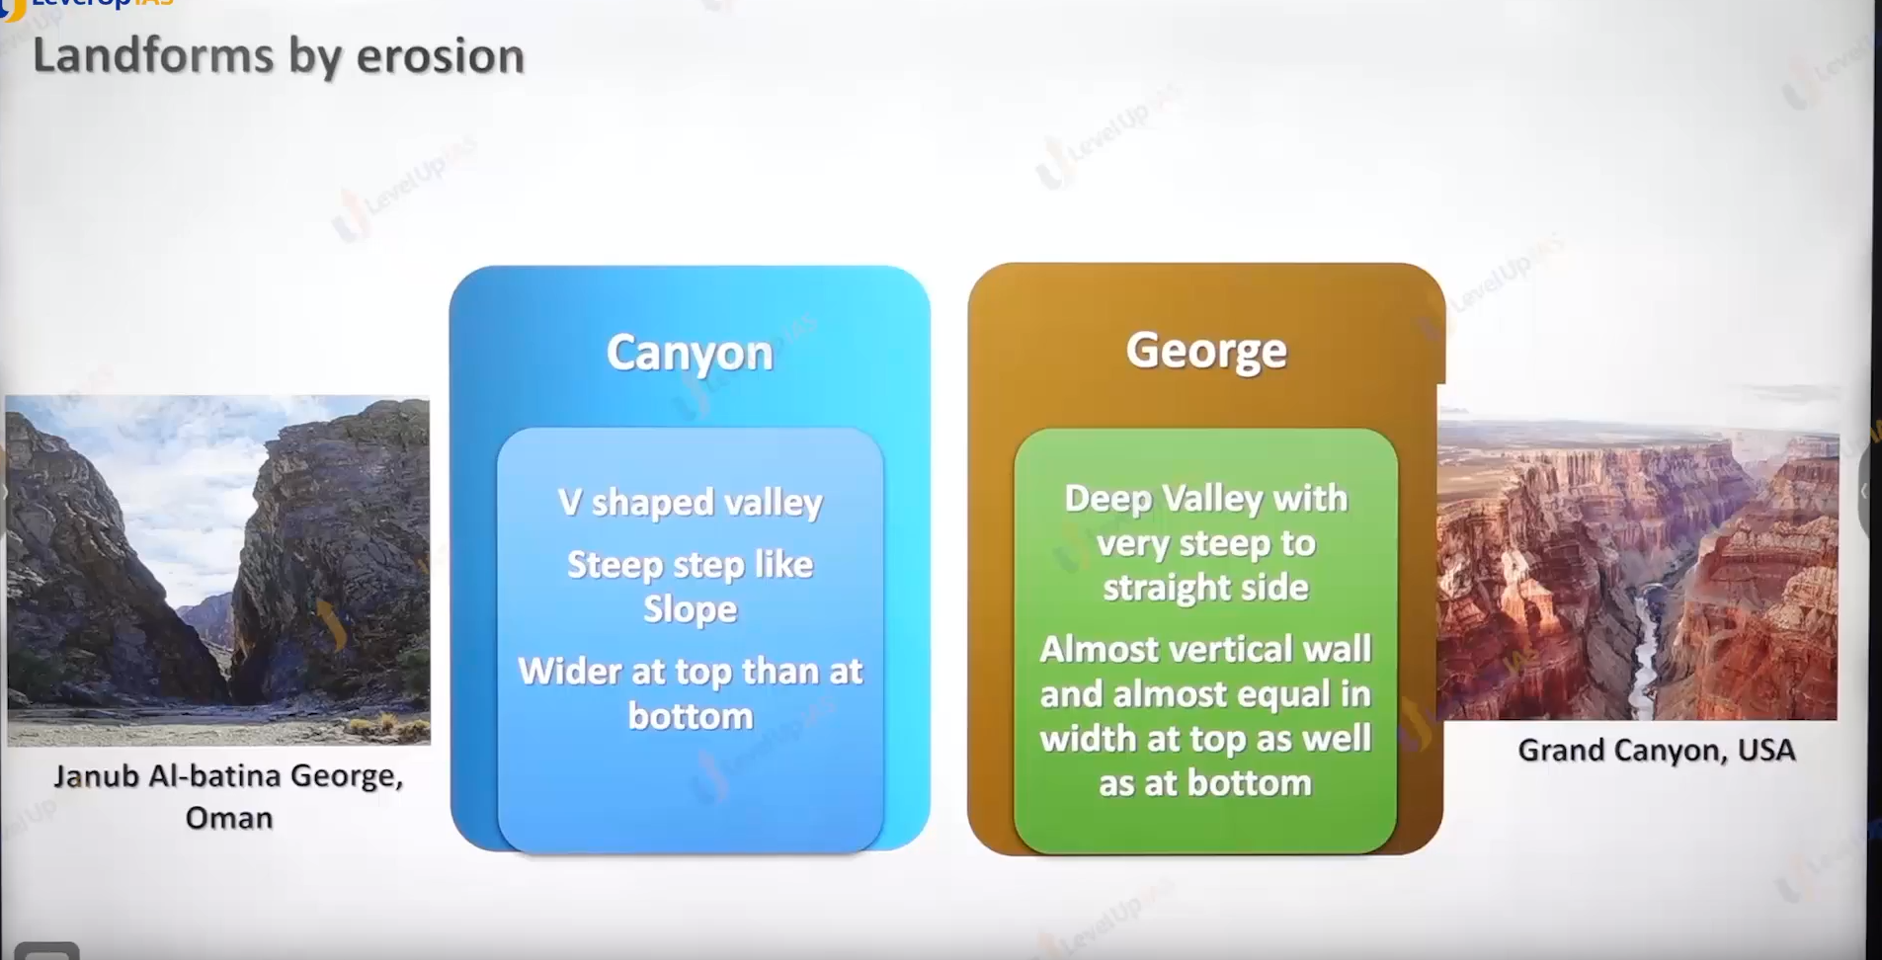

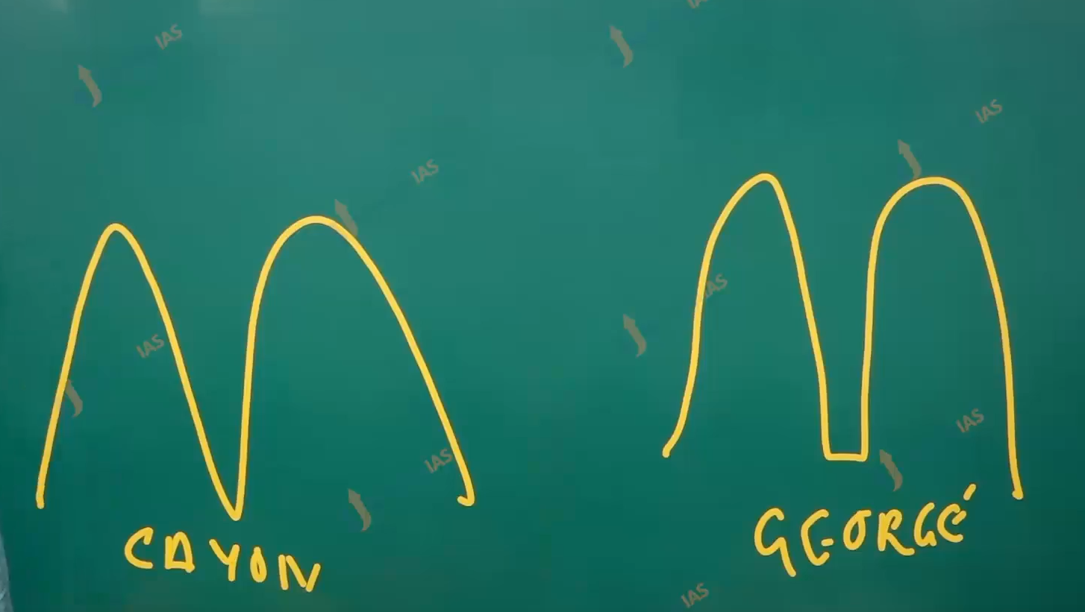

Erosion land from by the river:

1. George
2. Canyon
3. Plunge pool and waterfall.
4. Pothole.

Pothole erosion and pothole drilling.

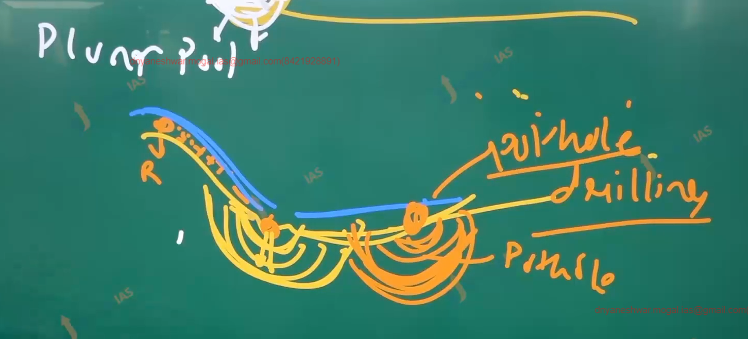



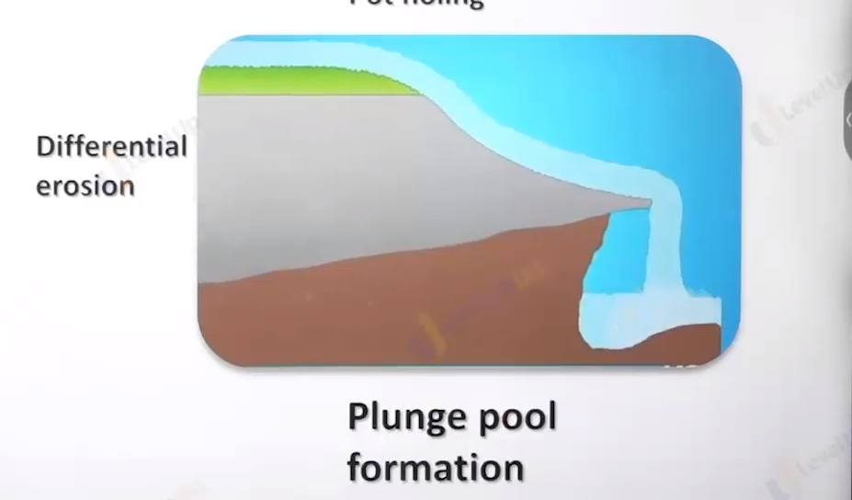

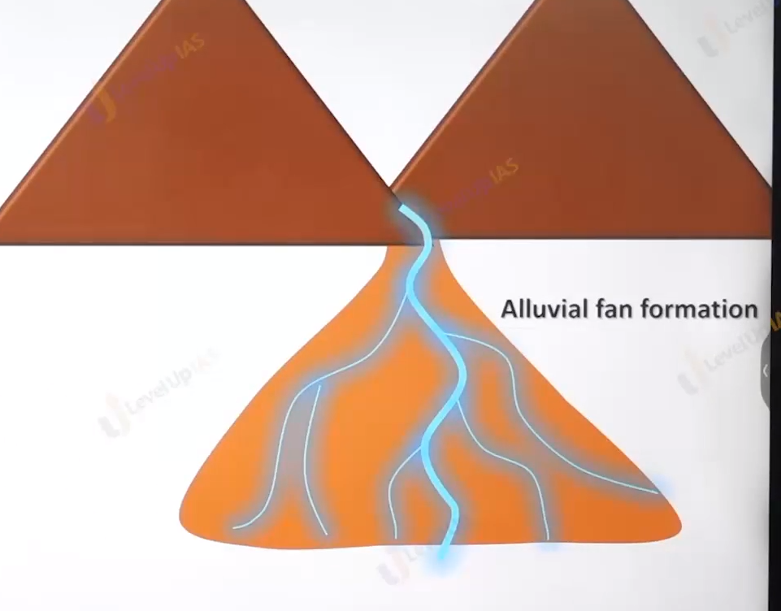

Deposition landform

1. Alluvial plain
2. Flood plain
3. Natural leavy
4. delta.

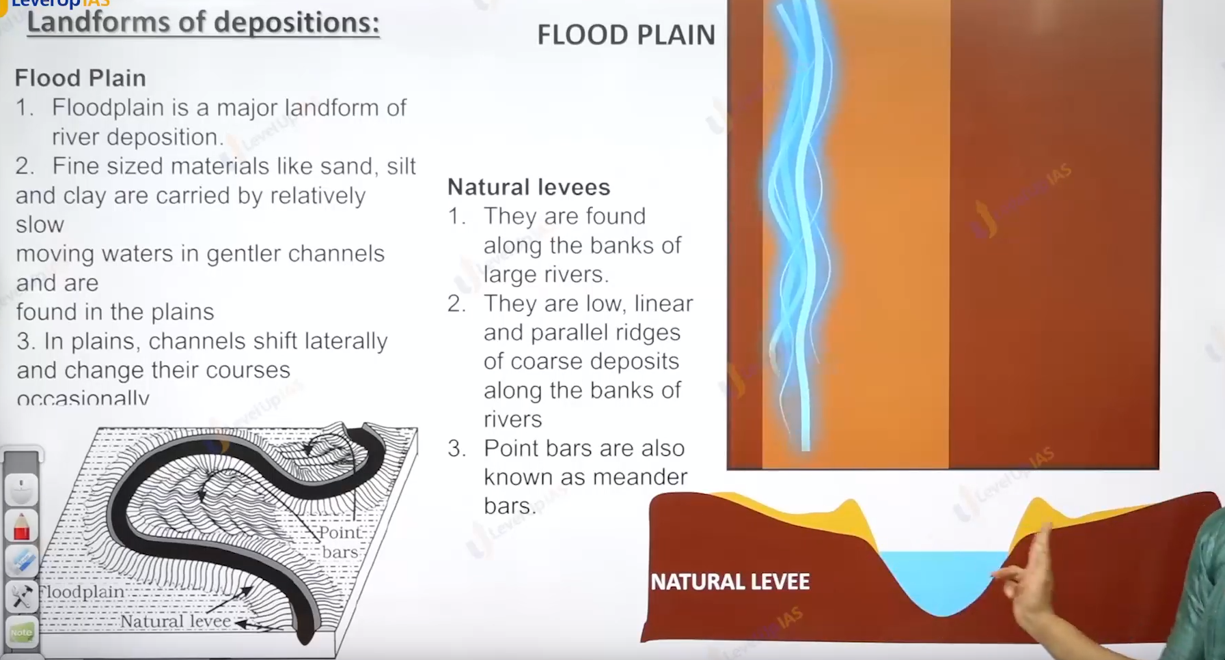

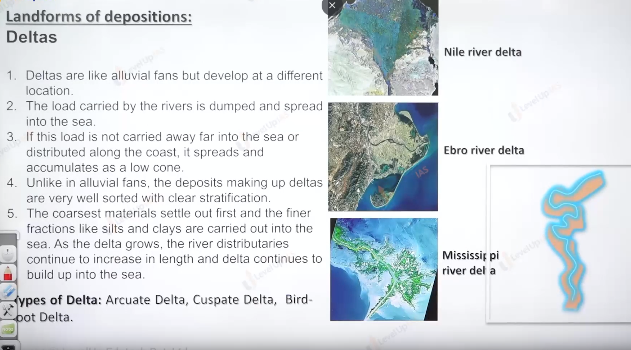

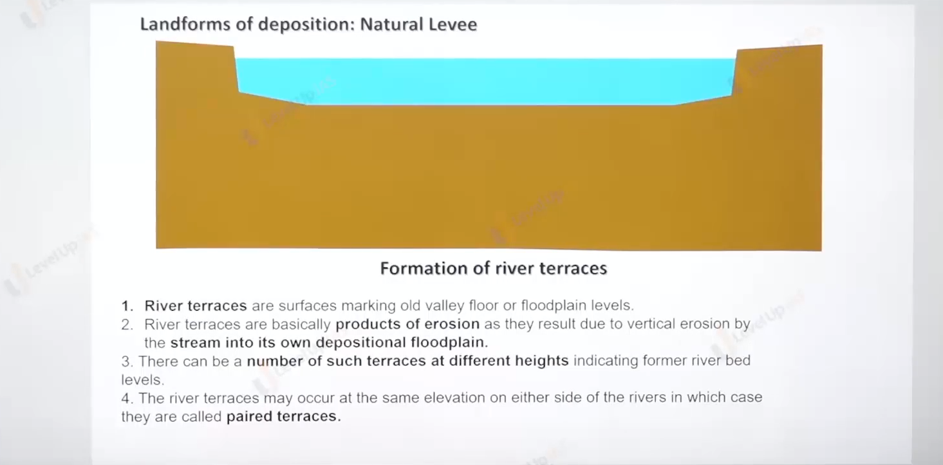

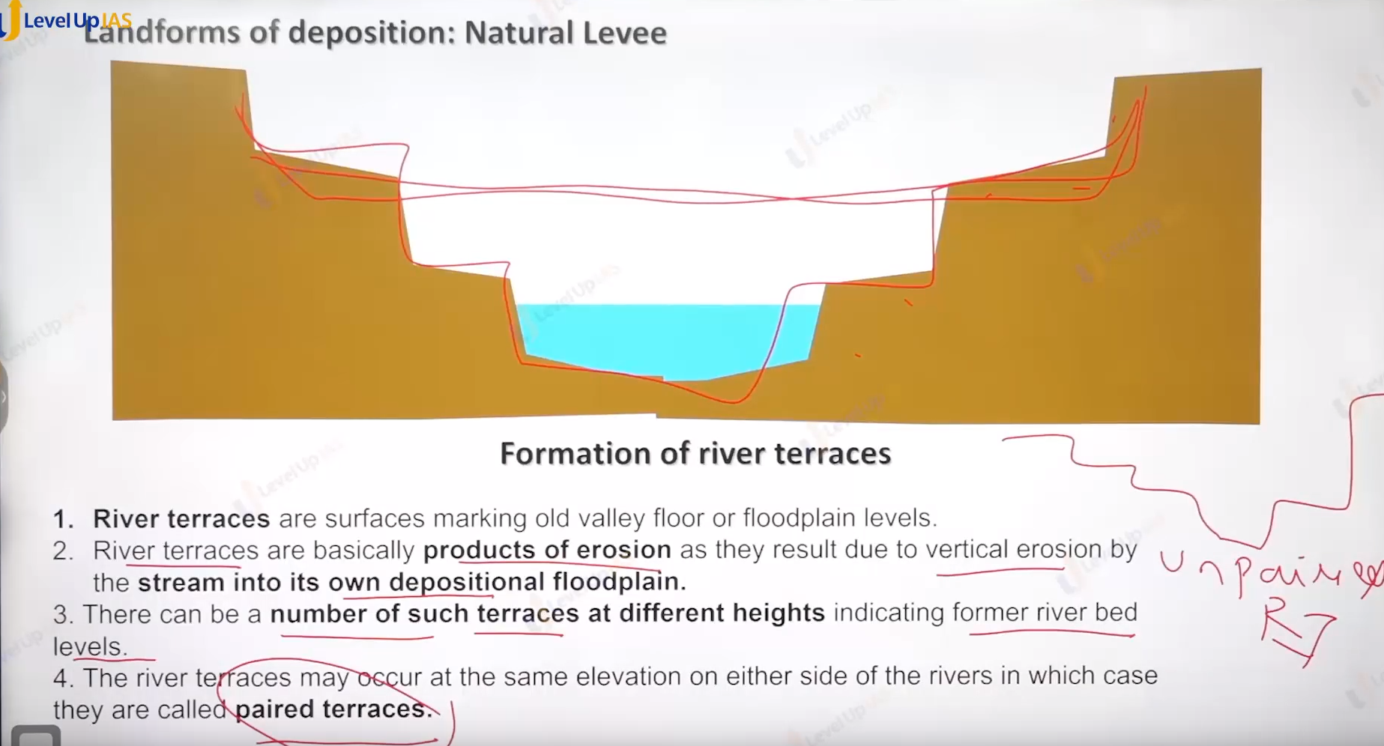

Ground water erosion.

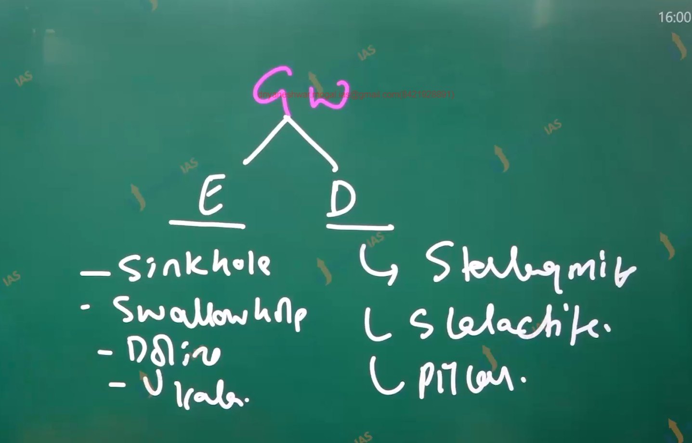

Not all time erosion happened when it limewater erosion from.

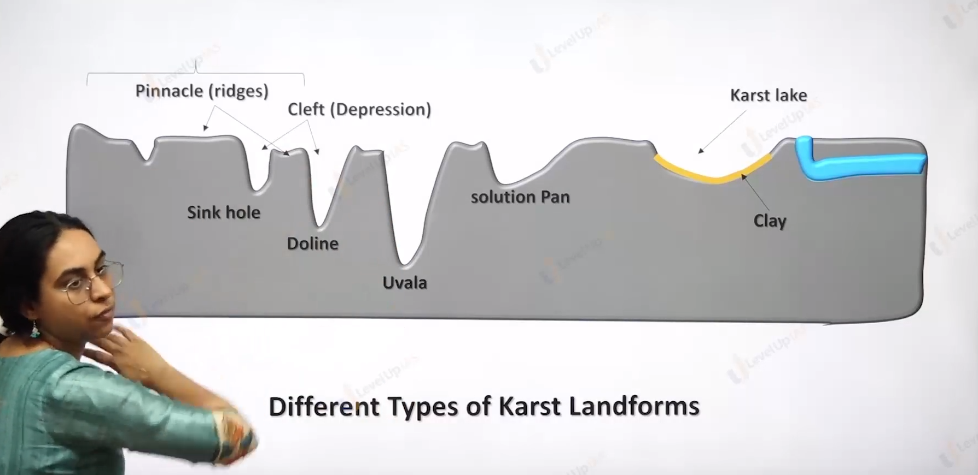

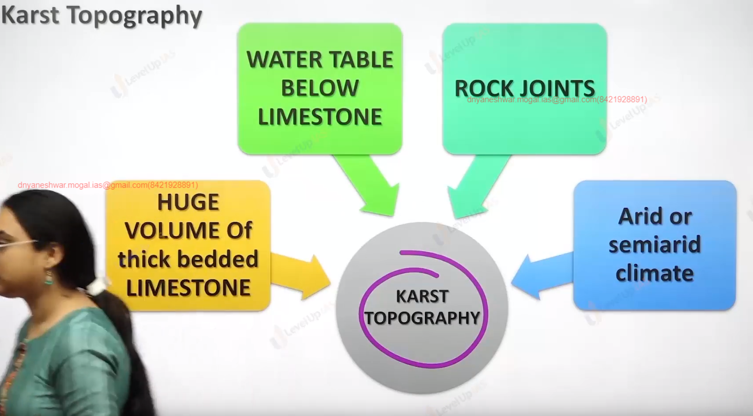

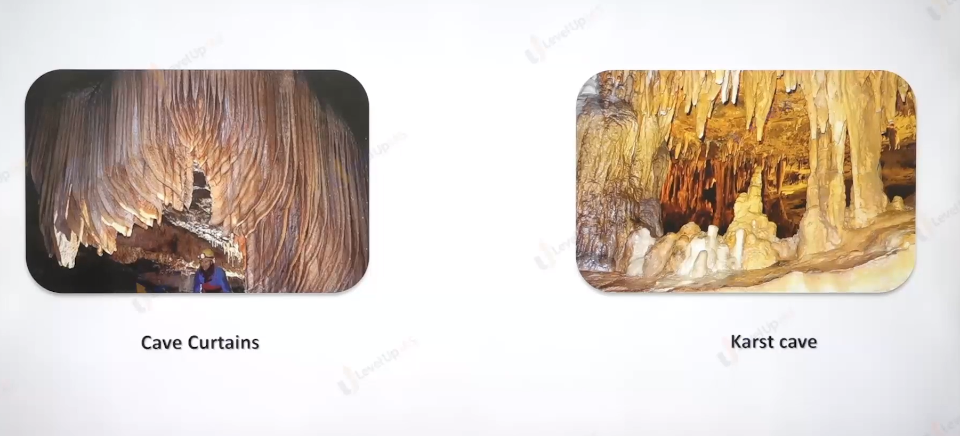

1. Cast erosional landforms:
2. sink hole
3. swallow hole.
4. Collapsing.
5. Uvala
6. Doline.
7. Limestone
8. Cave
9. Solution pan
10. Depositional landforms.
11. Stalactite hangs cave curtains.
12. Stalagmites rise up

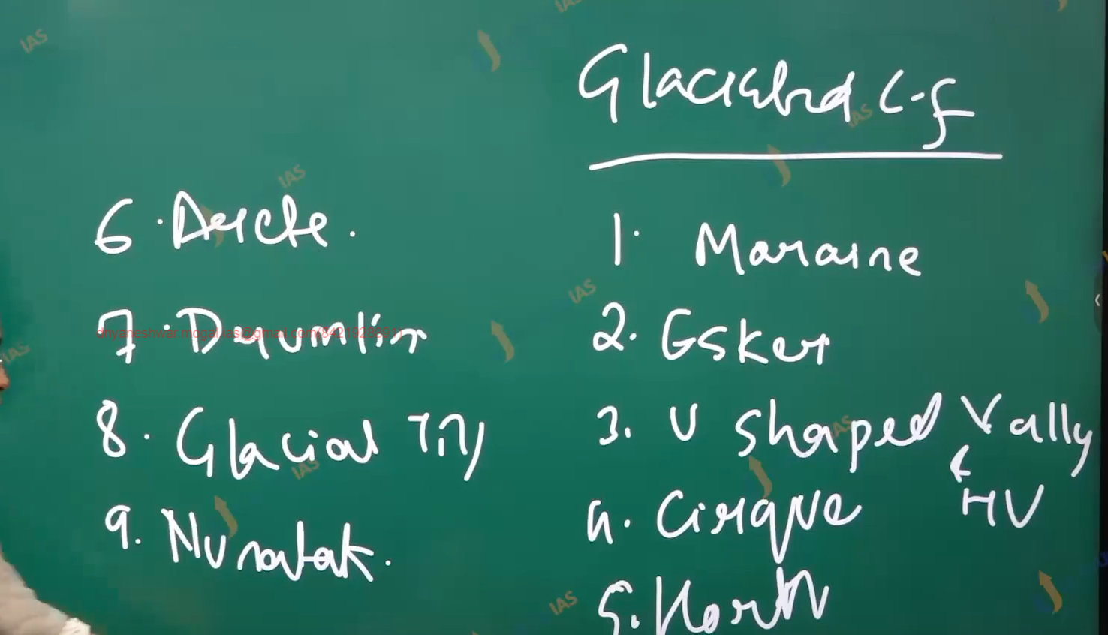

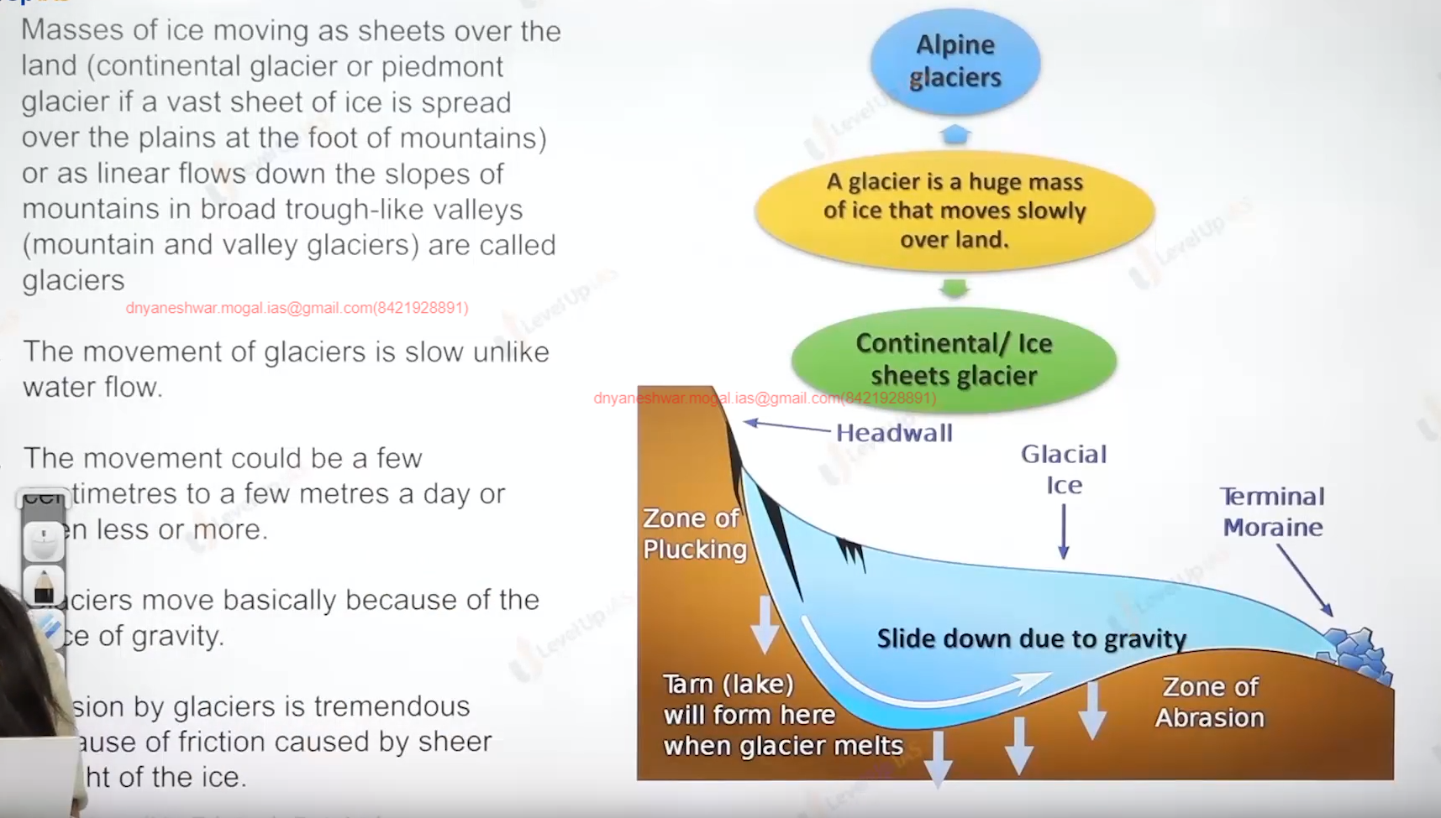

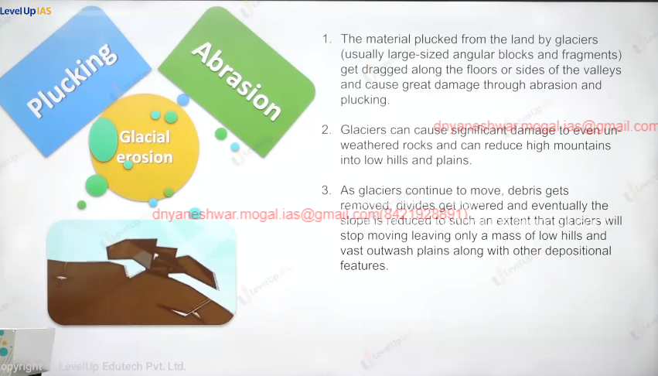

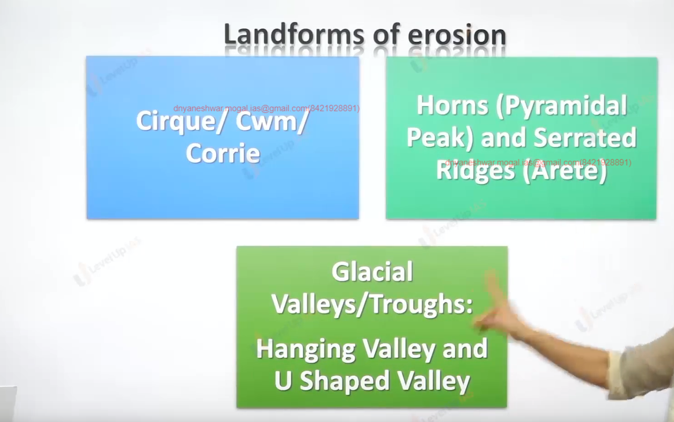

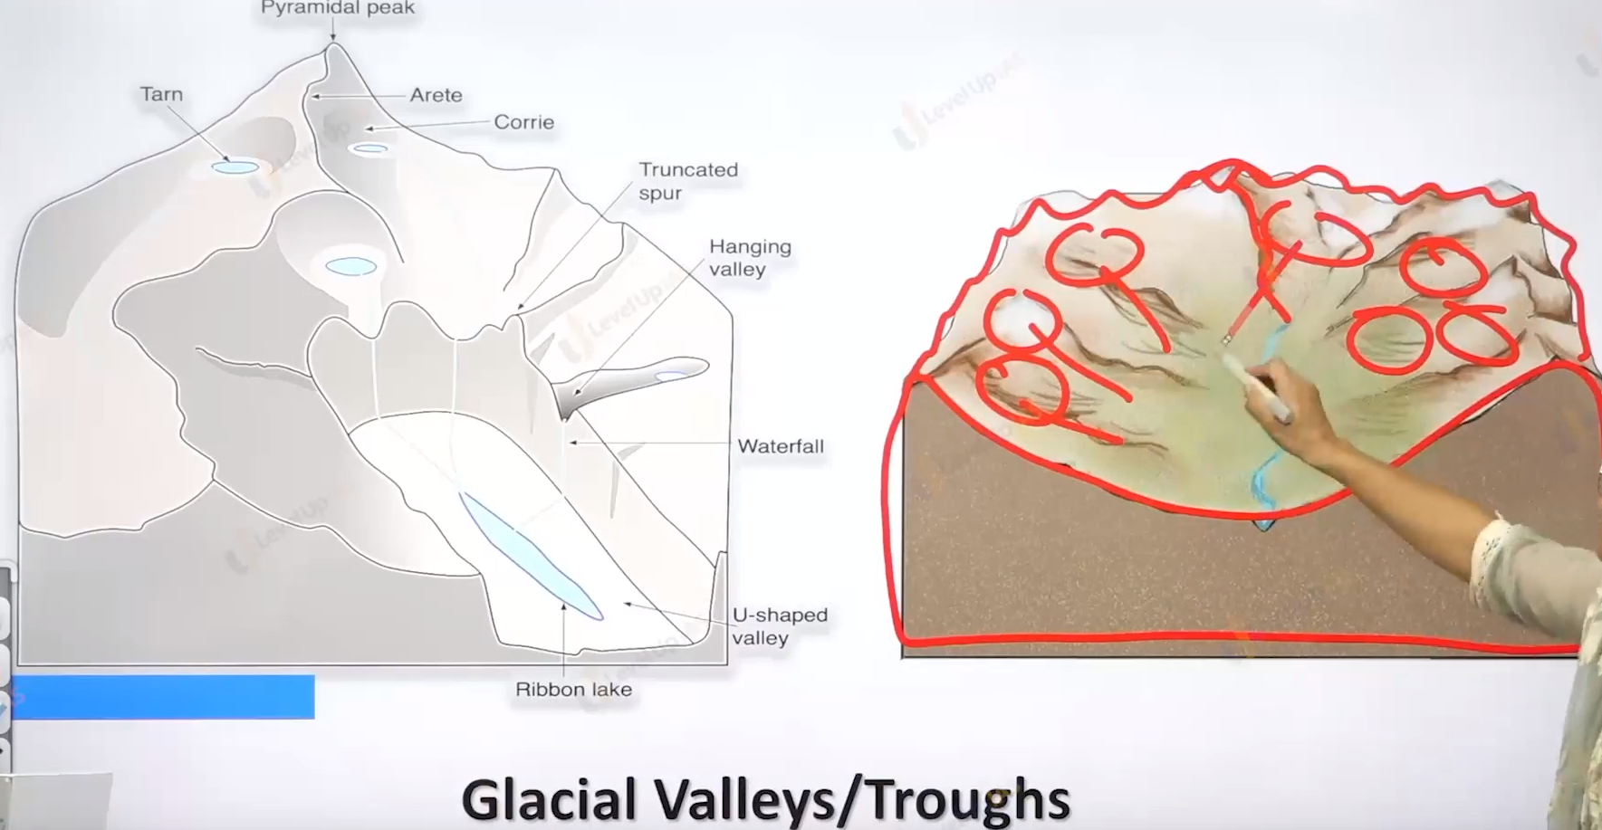

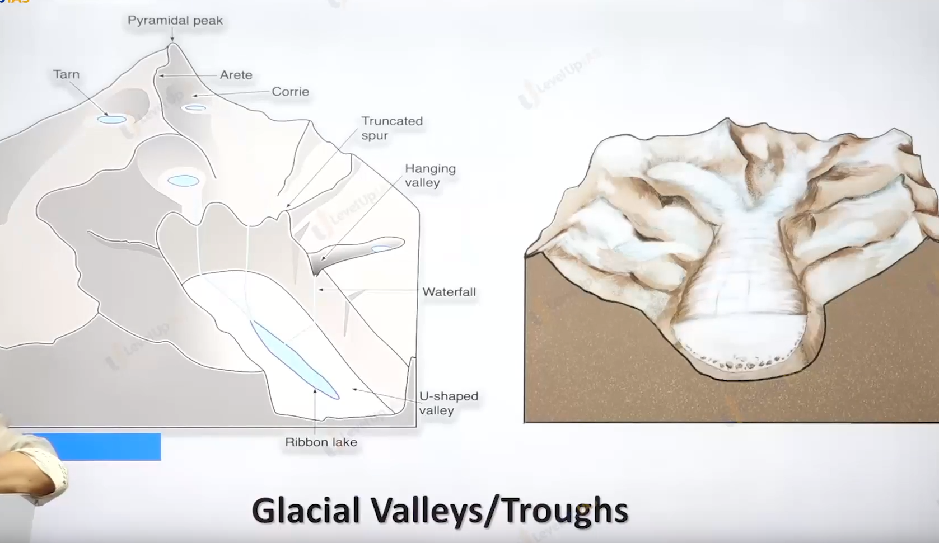

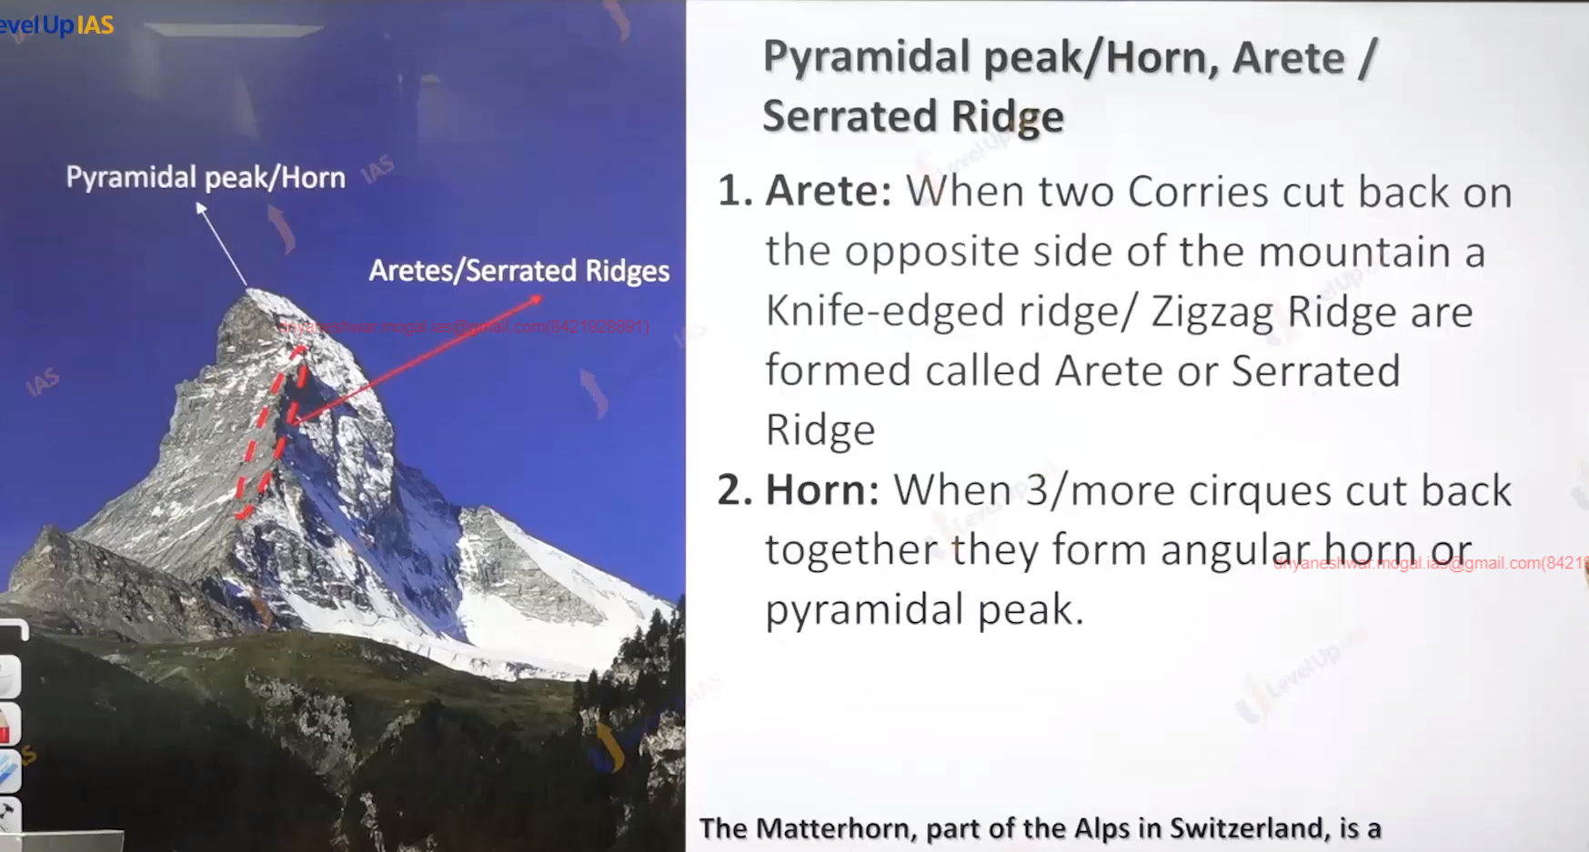

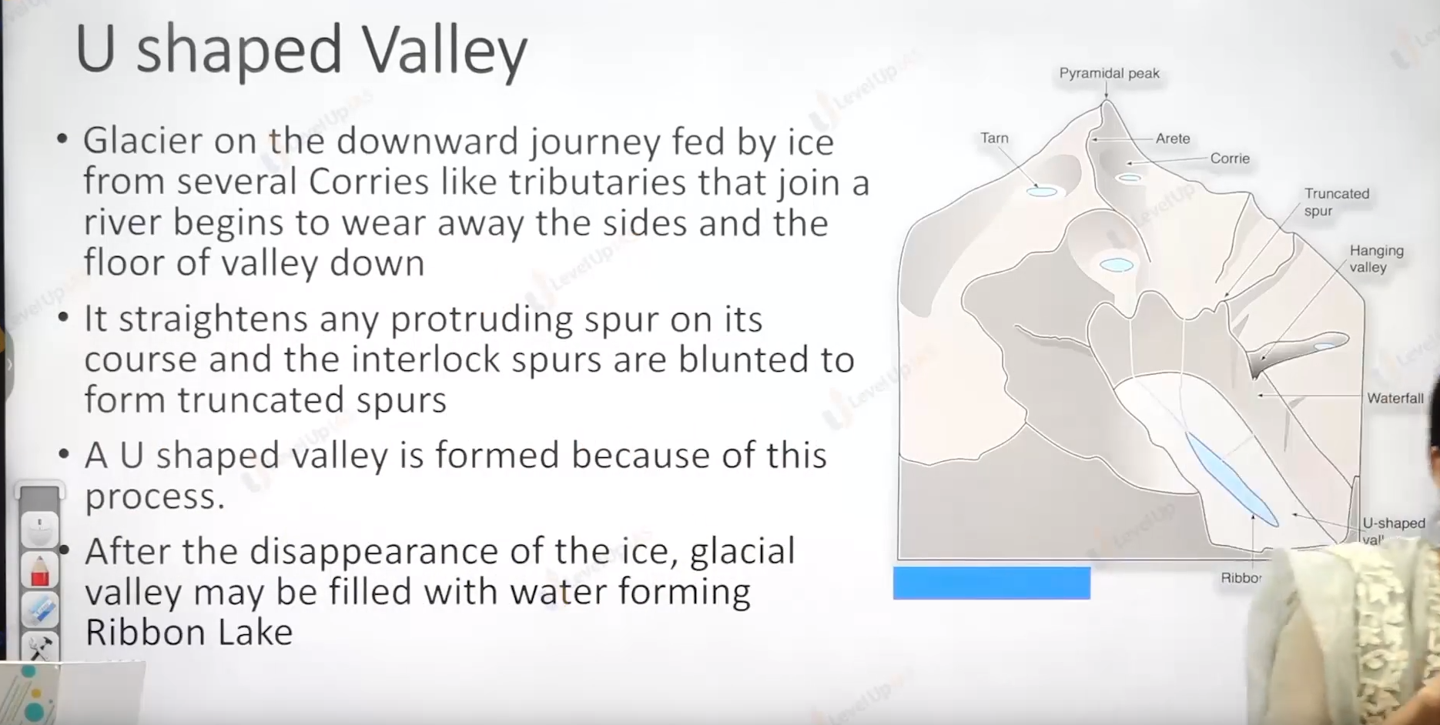

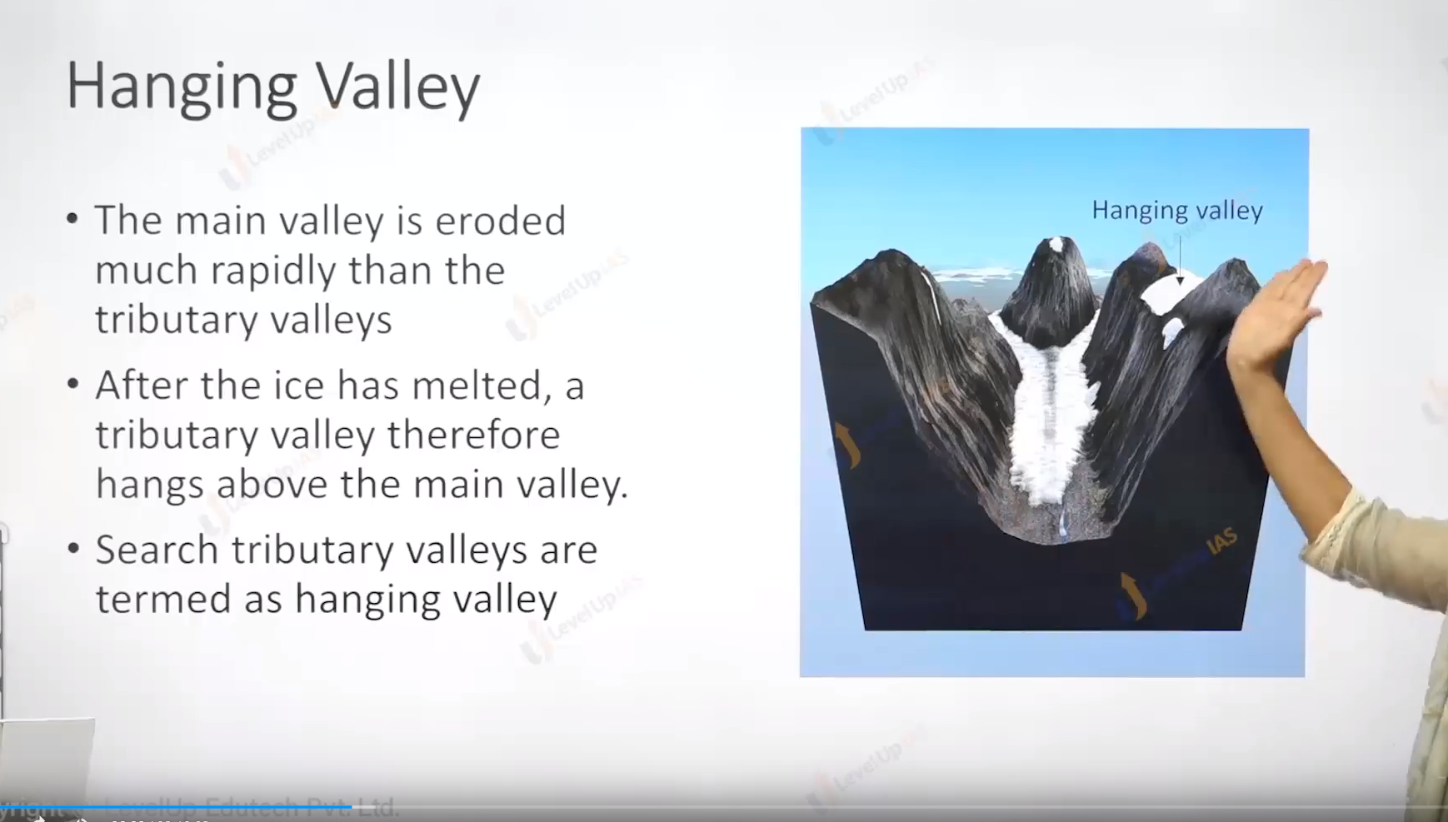

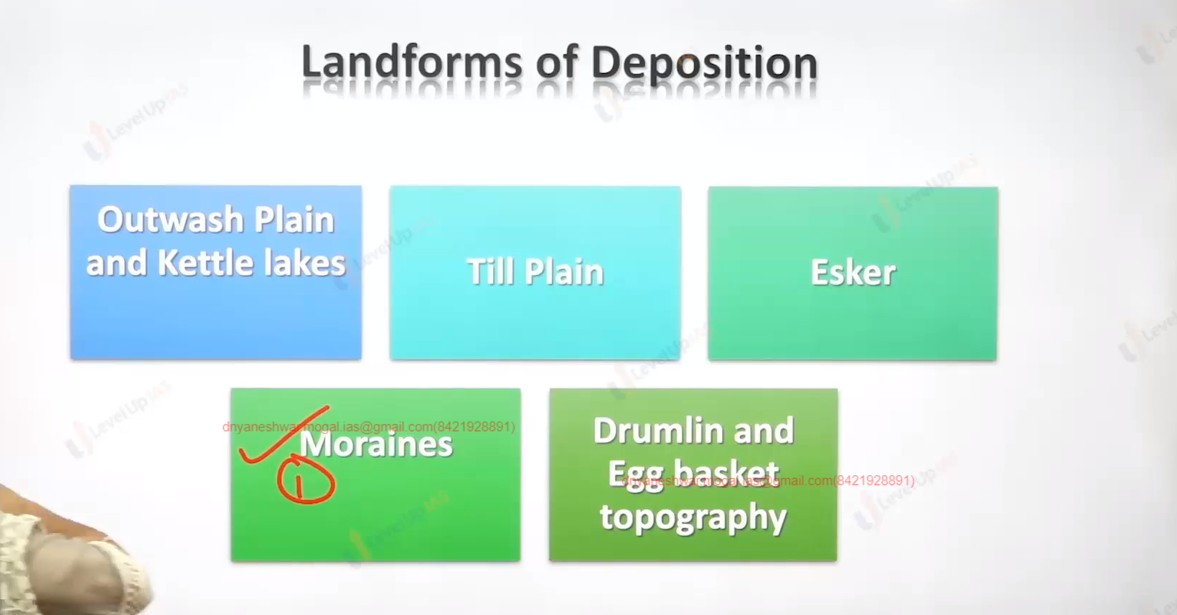

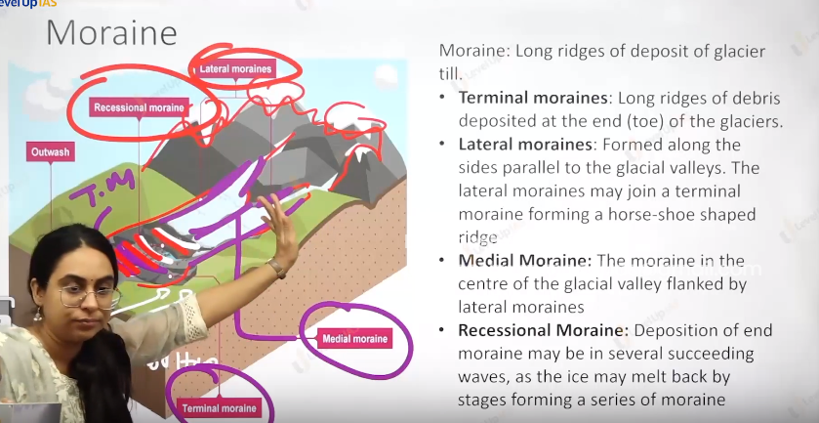

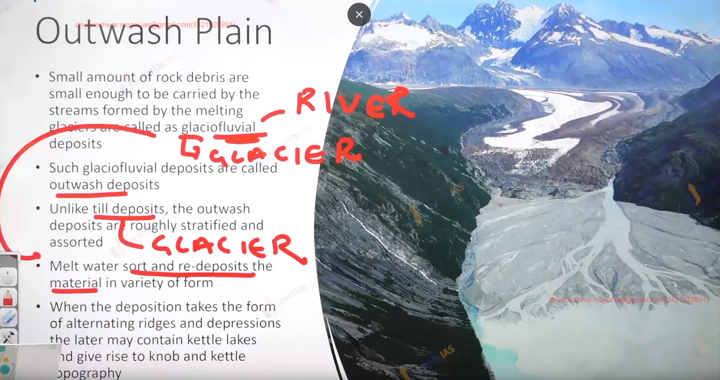

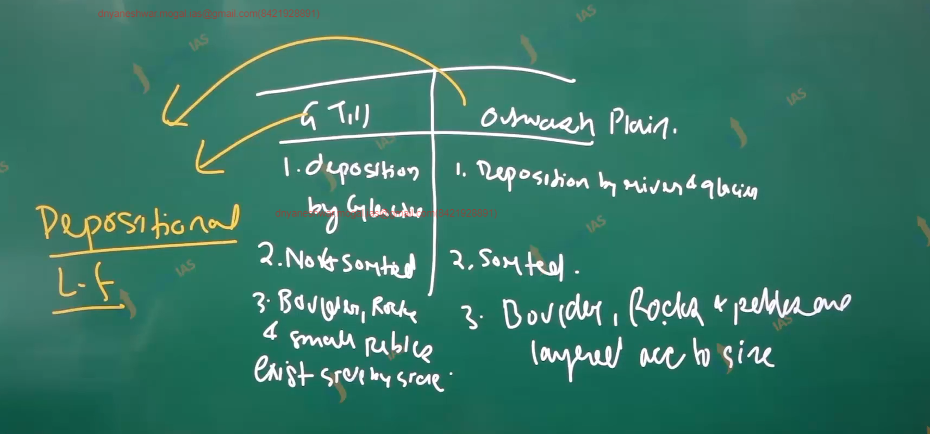

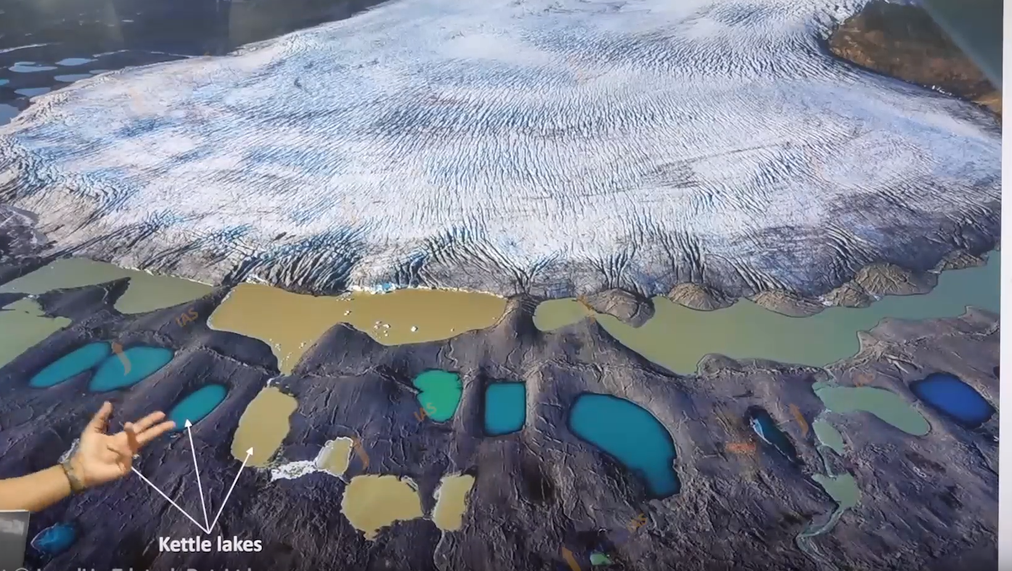

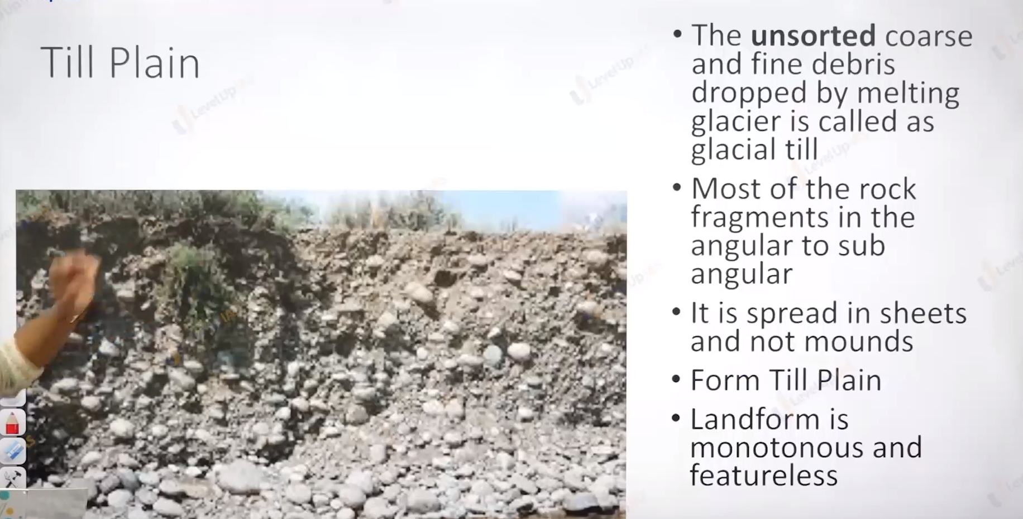

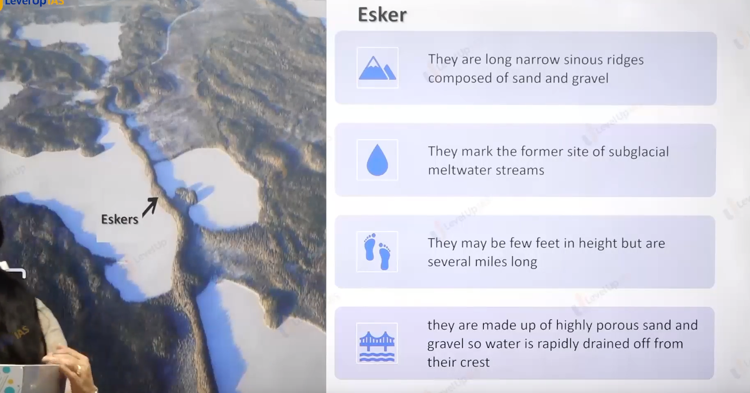

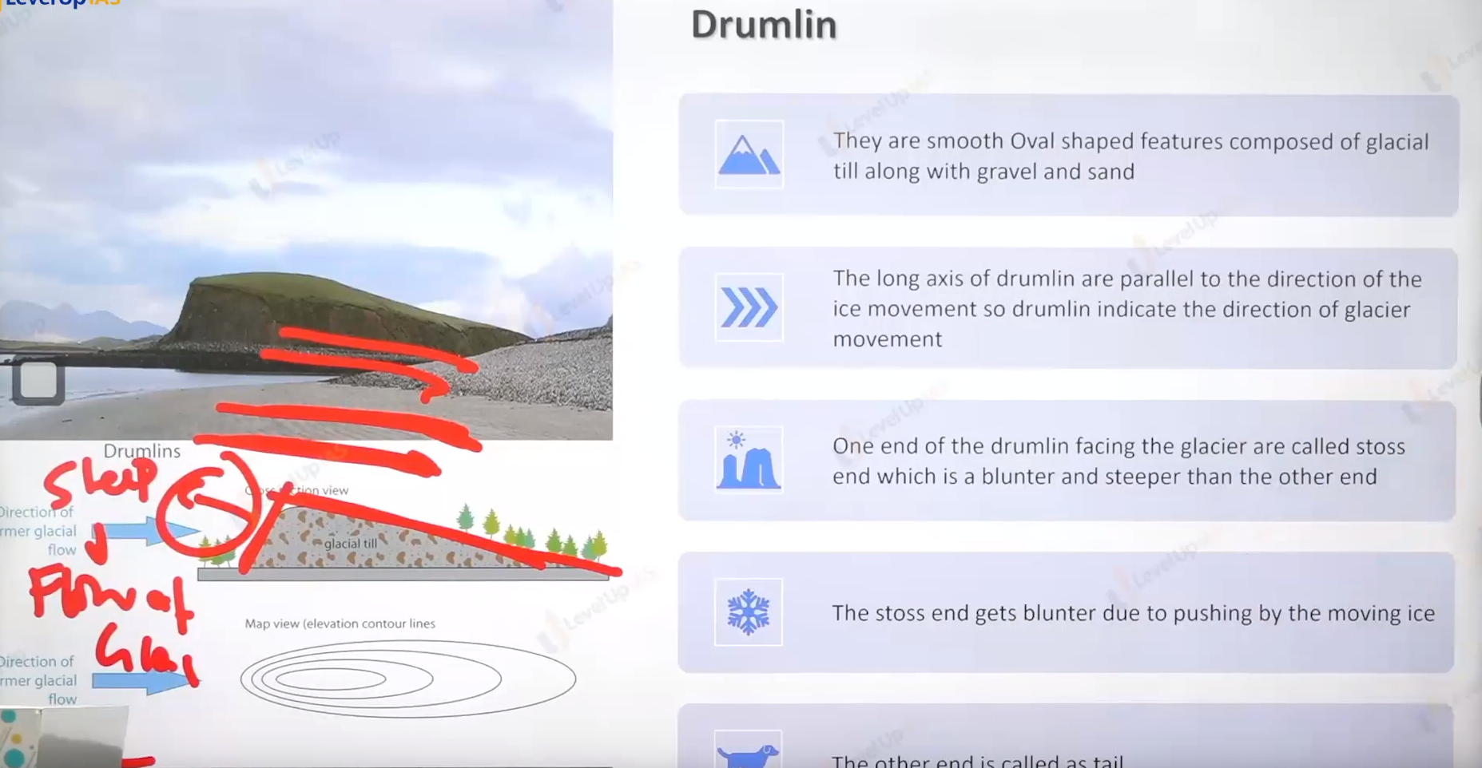4

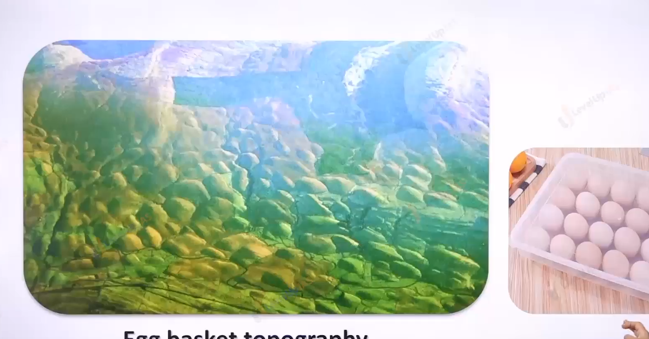

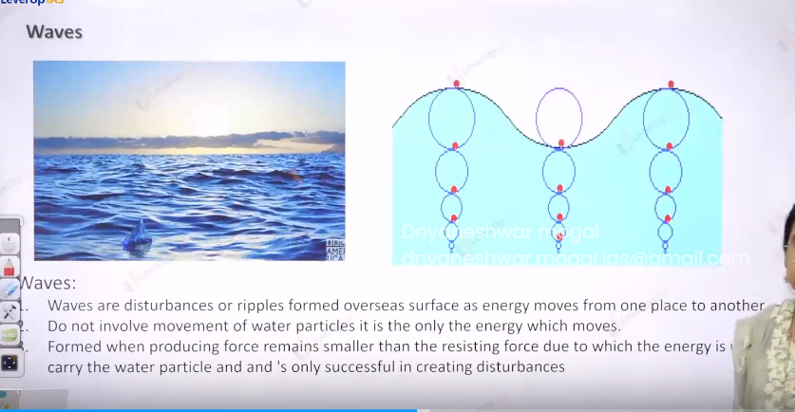

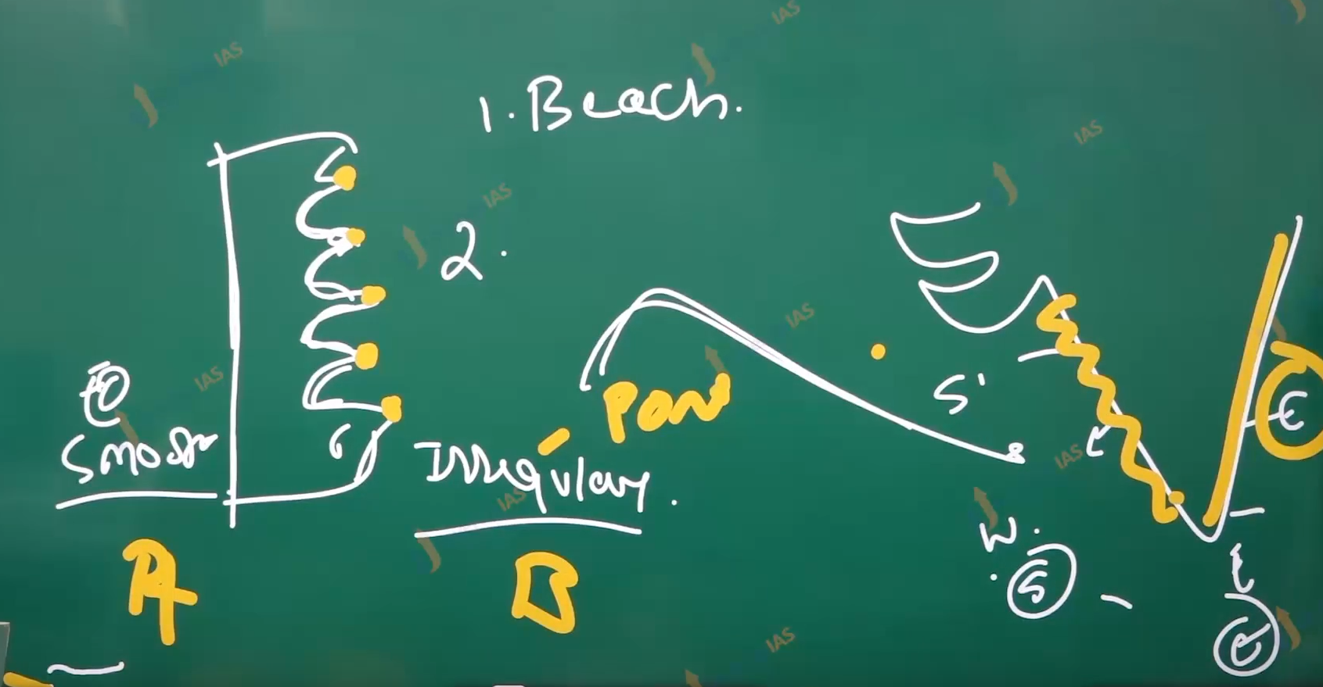

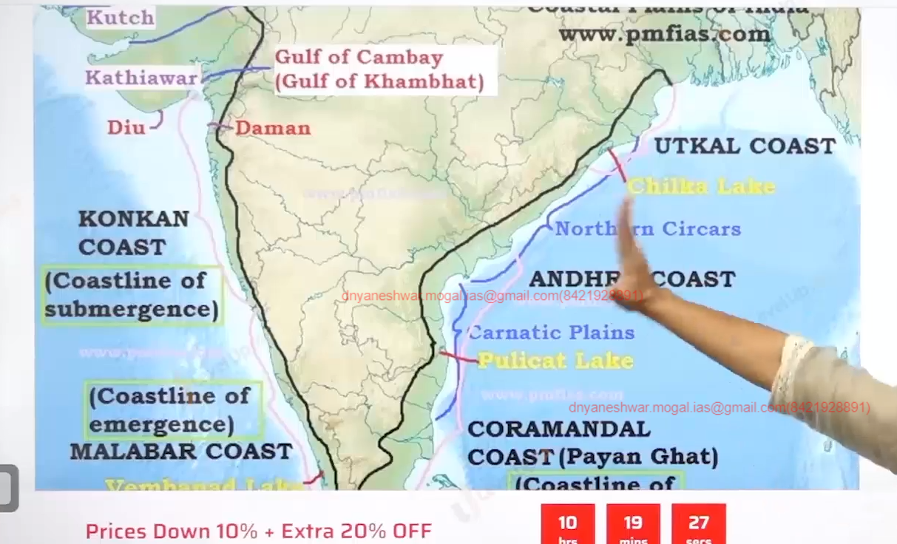

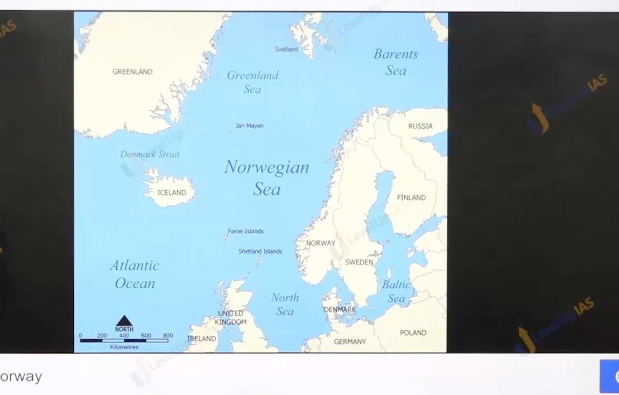

Costal land forms

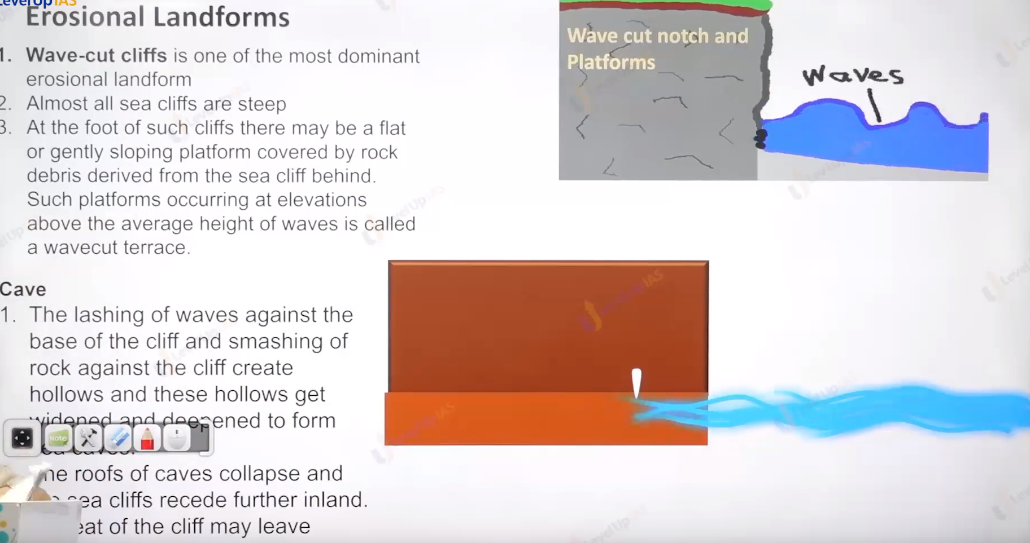

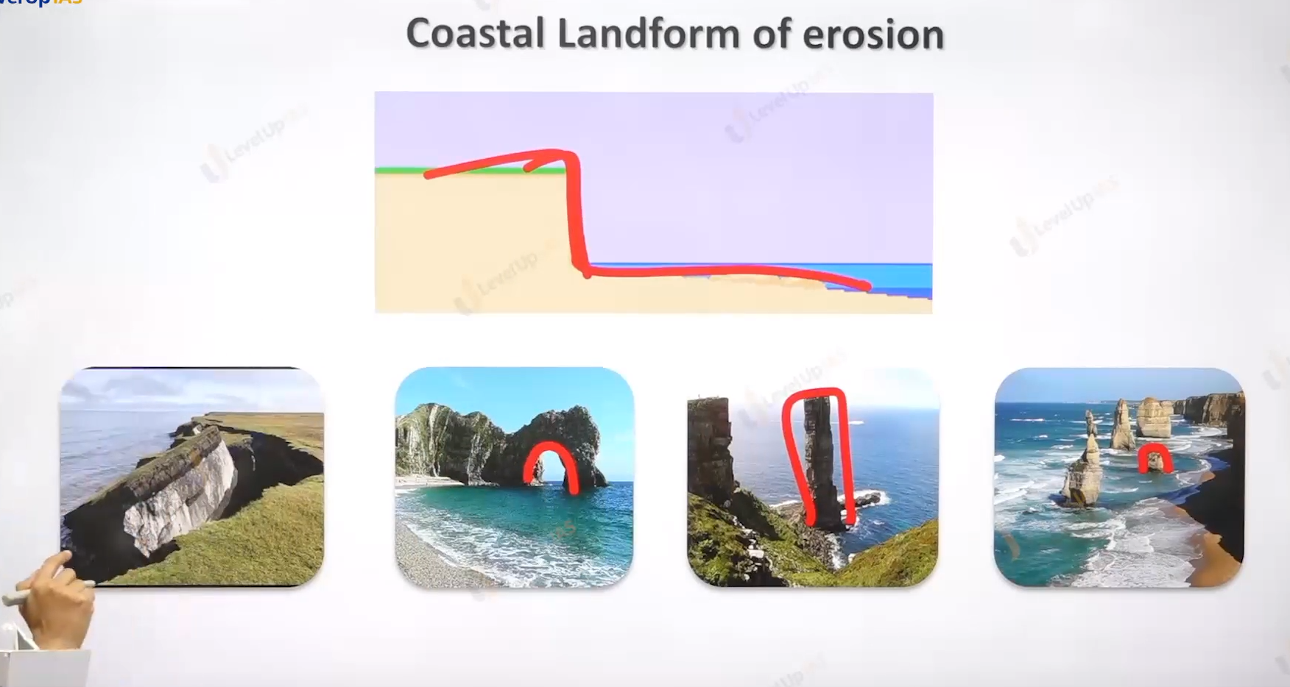

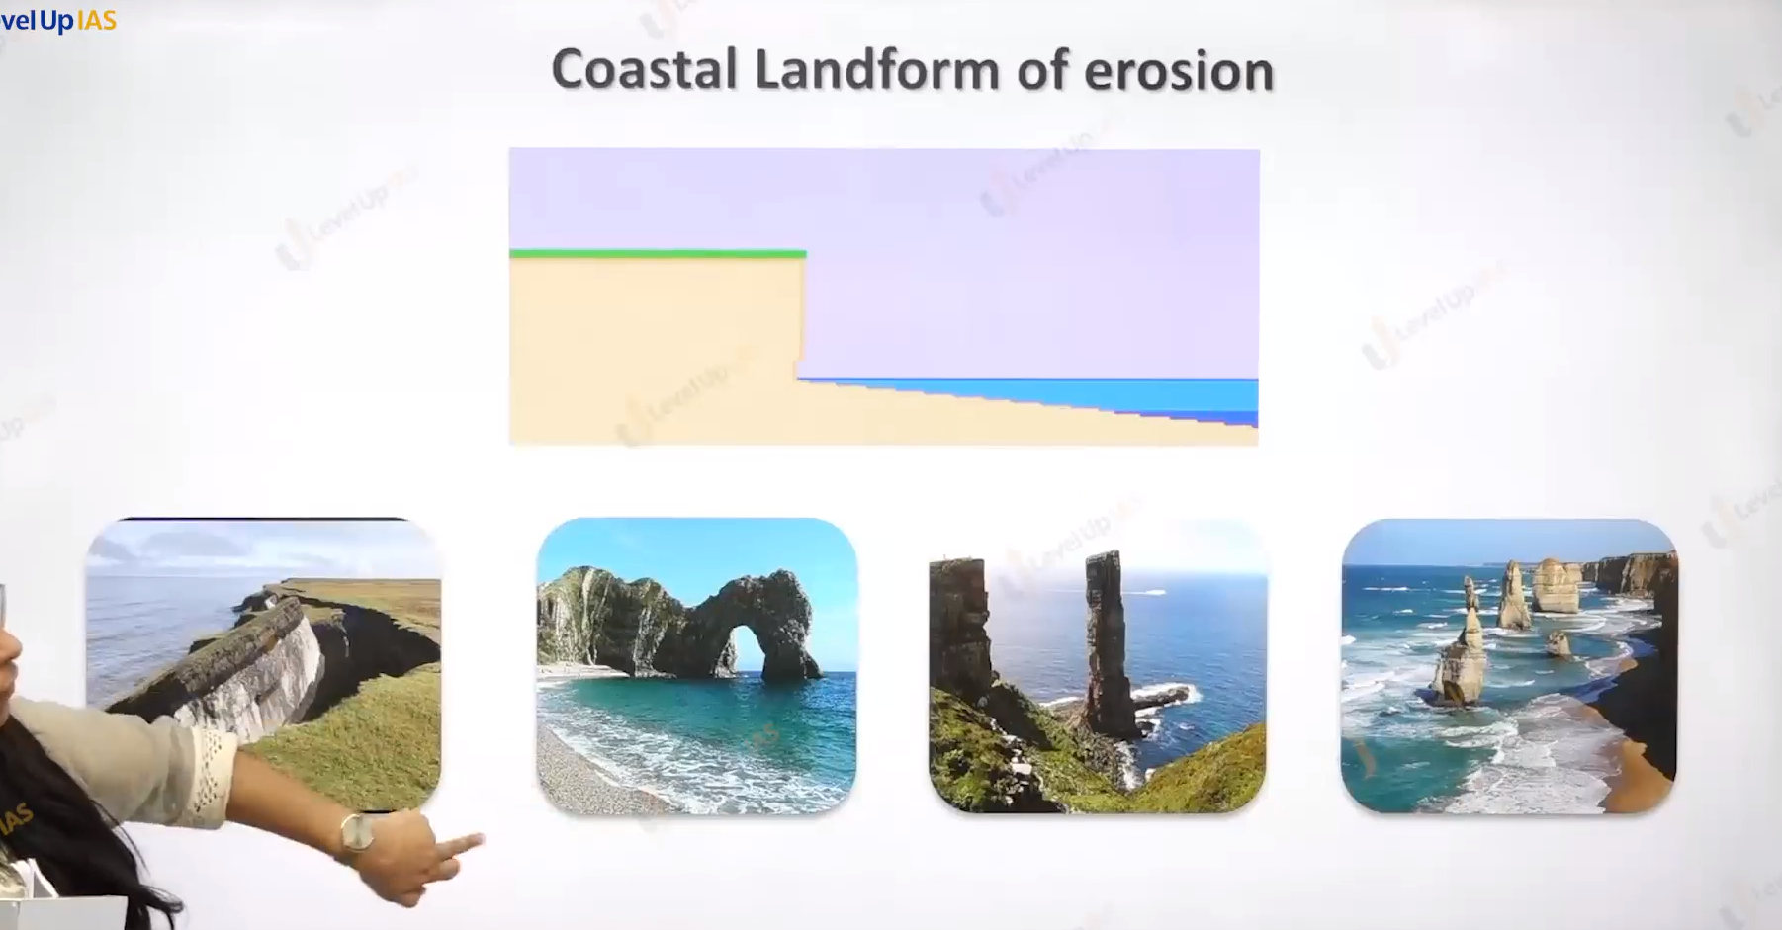



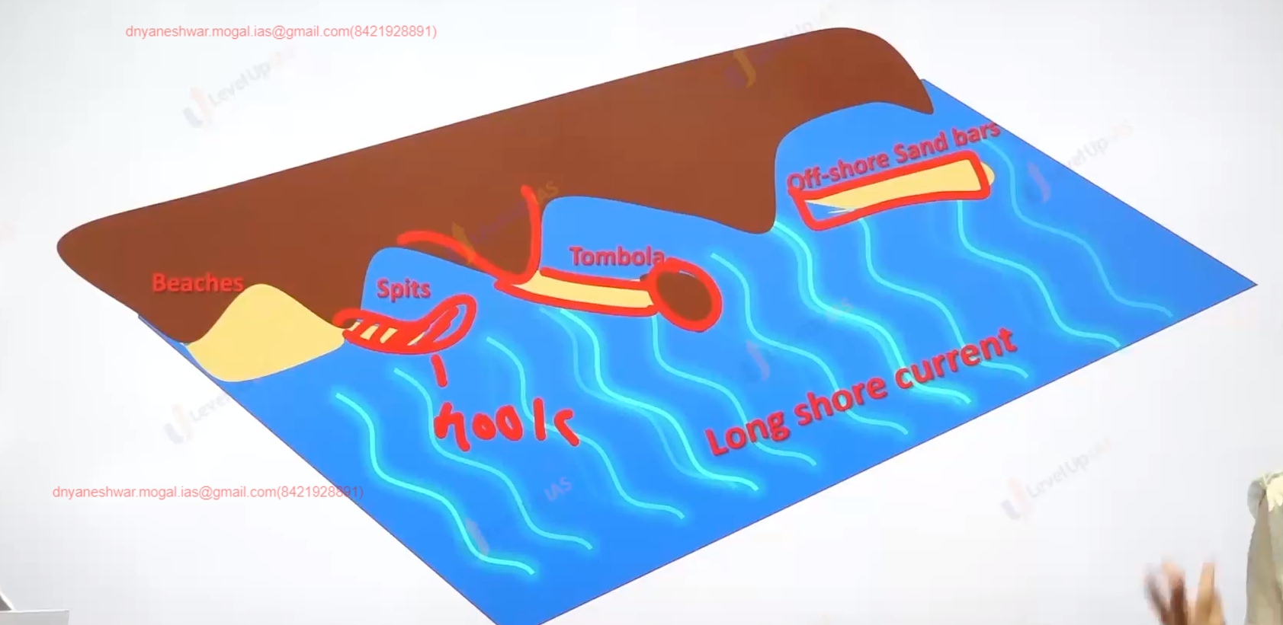

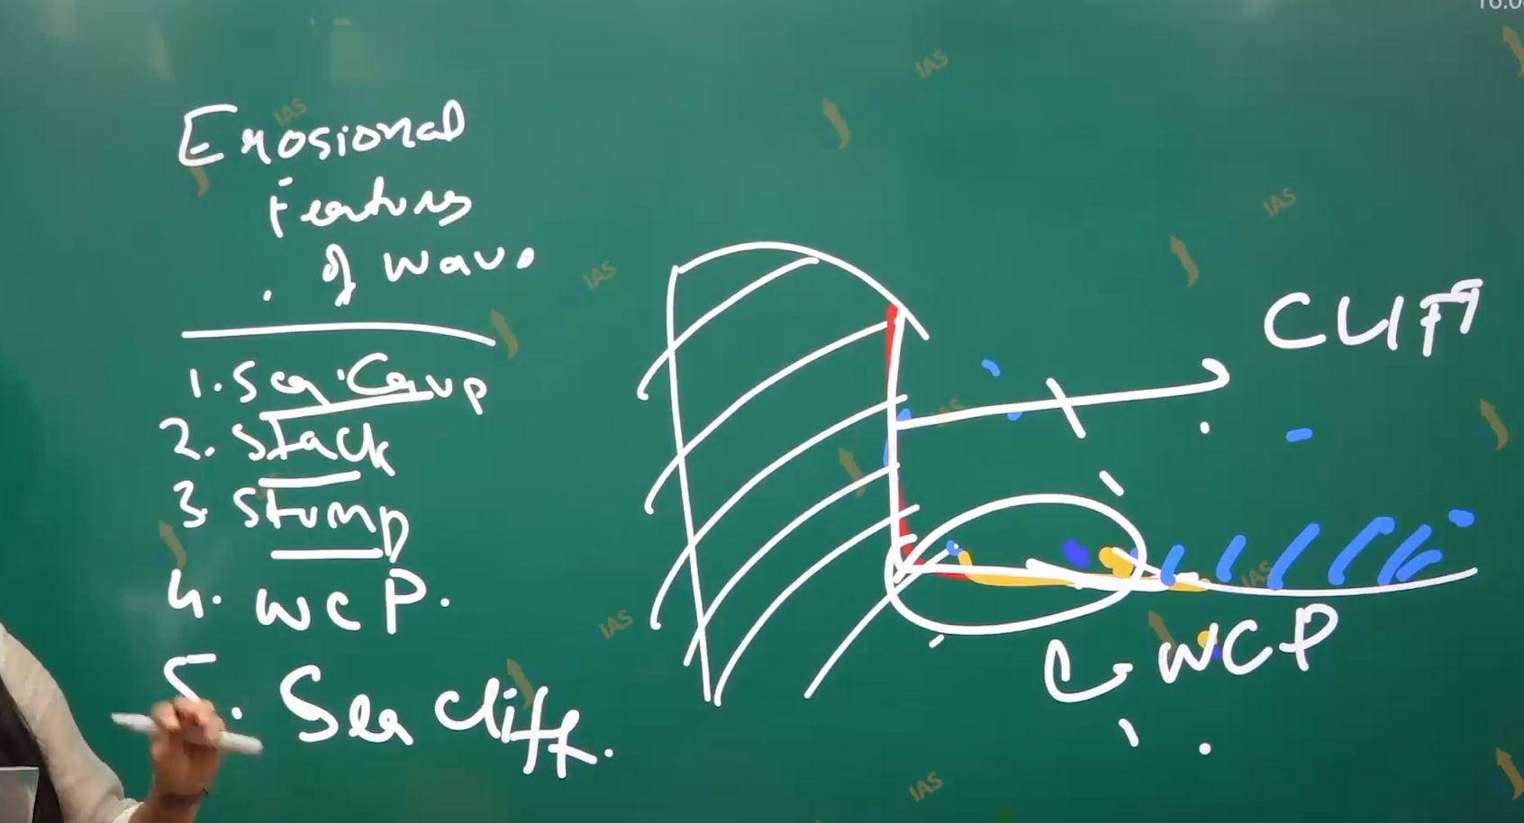

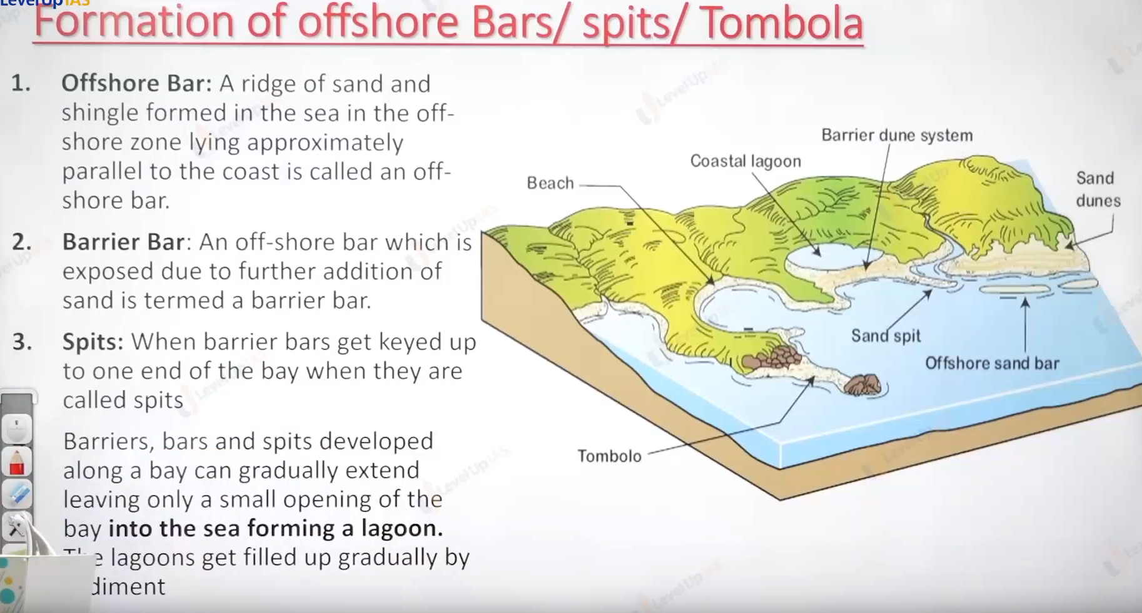

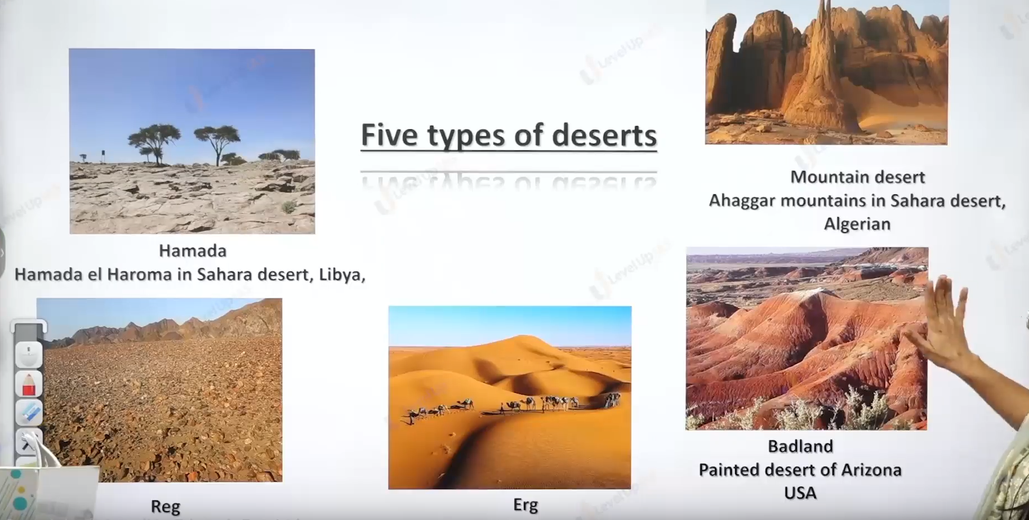

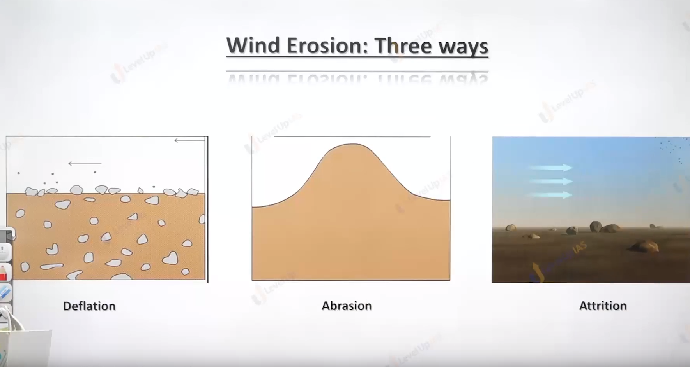

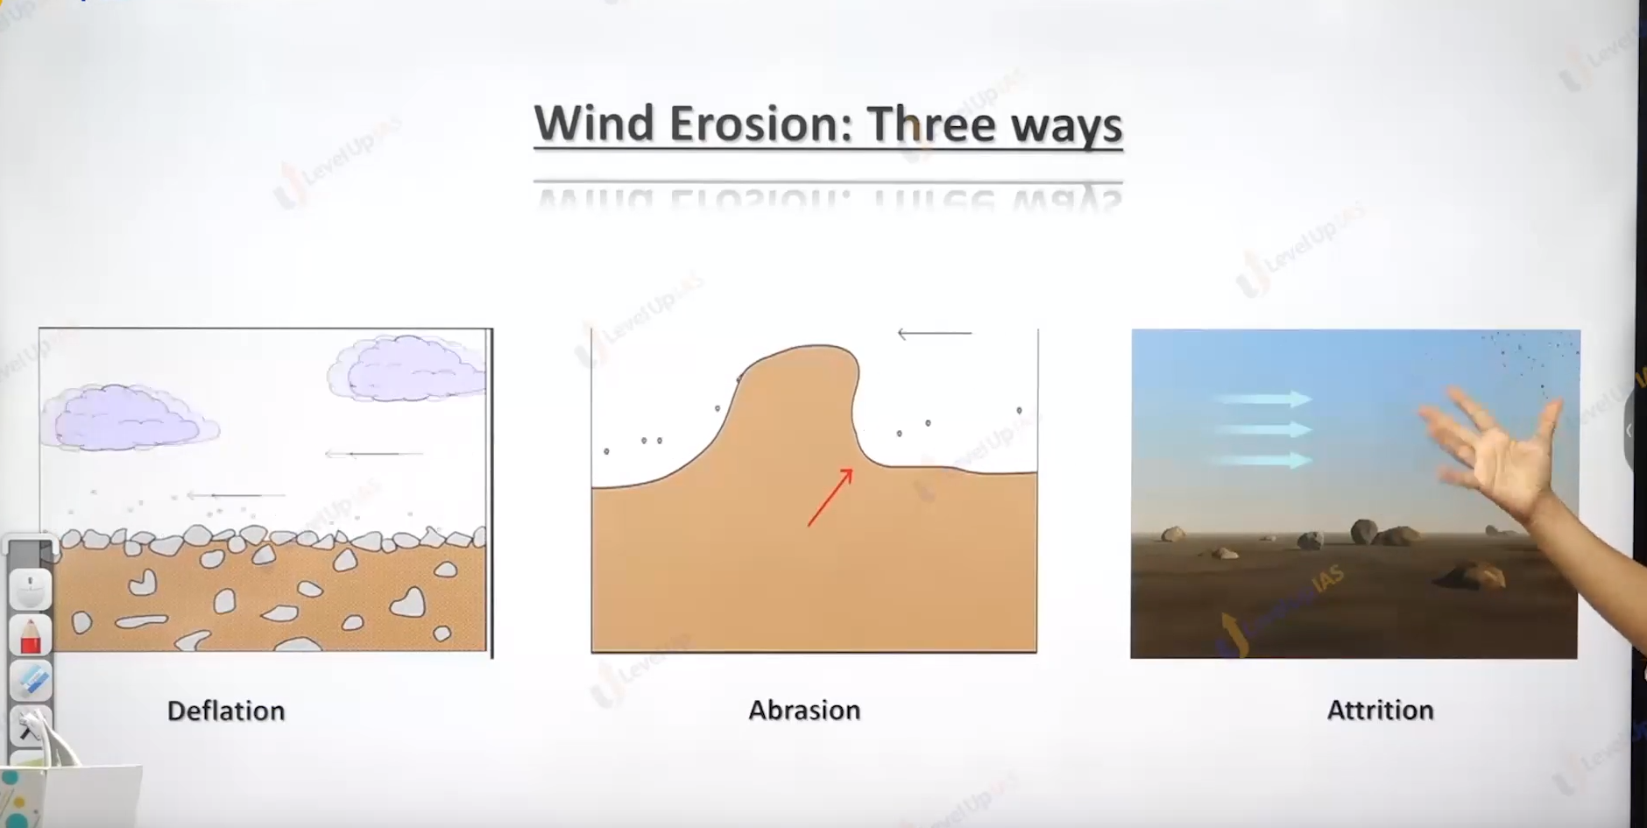

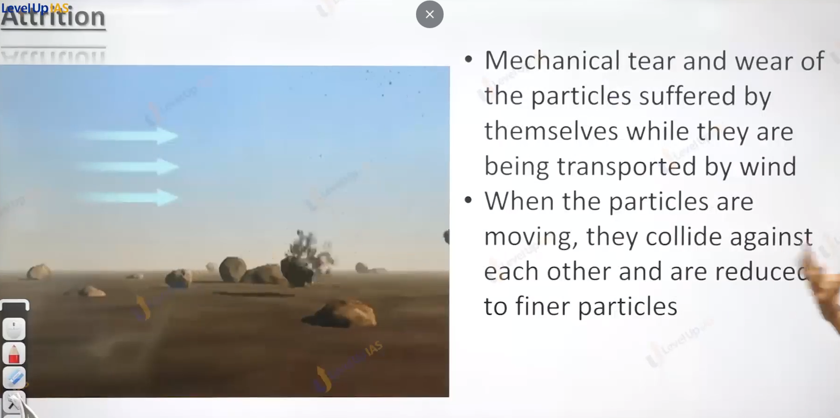

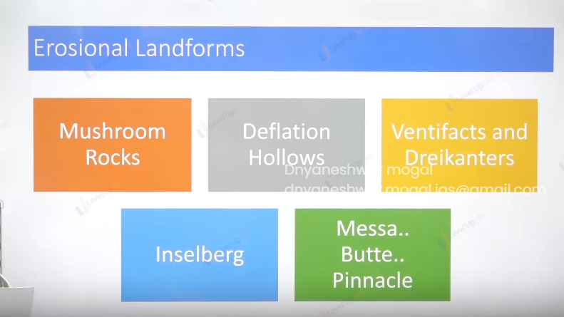g

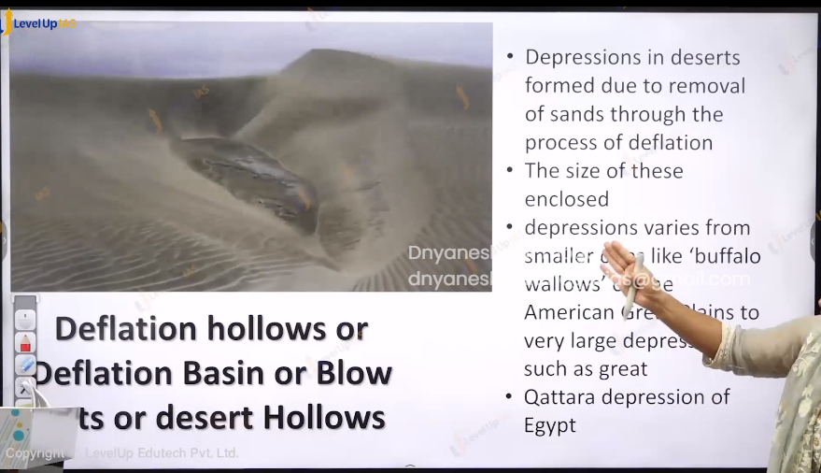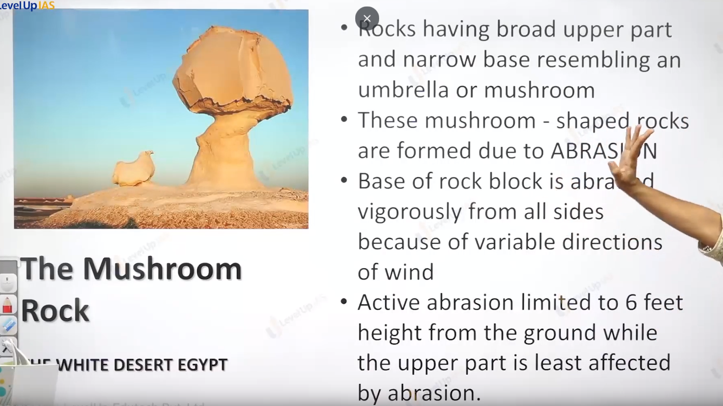

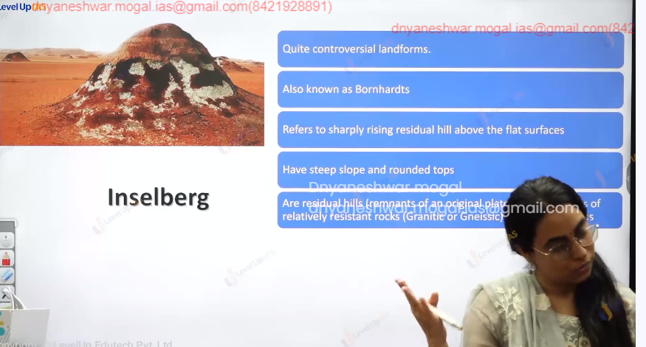

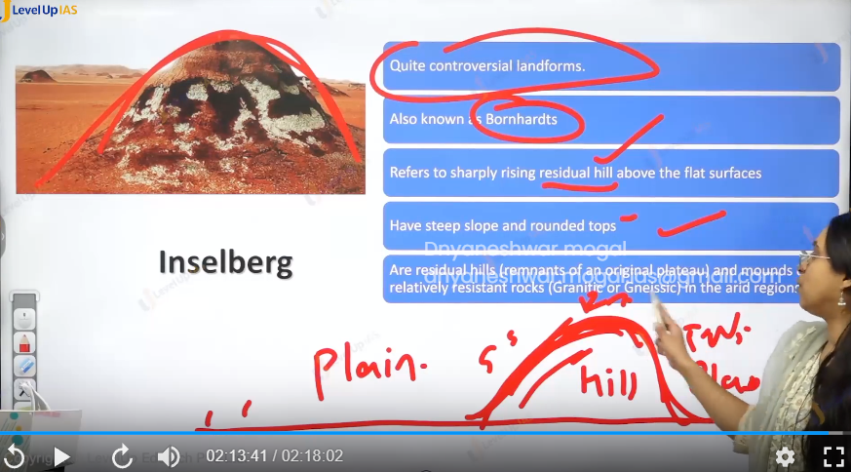r

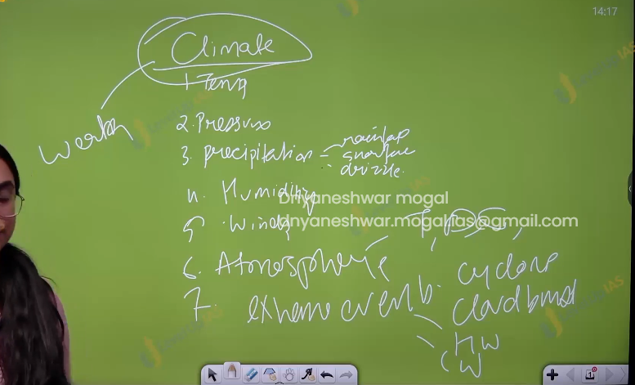

Climate

(14) Composition of Atmosphere and Layering

Climate :

1. Atmosphere.
2. Temperature
3. Pressure
4. Humidity
5. Precipitation ex rainfall, snowfall, grizzles.
6. Wind ex sea wind , trade wind , monsoon wind,
7. Extreme event cyclone, cloud bust, heat wave cold wave.

Atmosphere: blank of the gasses that surround the earth. It is composed of gassees dust particles water vapors pollutant, ions, nitrogen, oxygen. Helium.

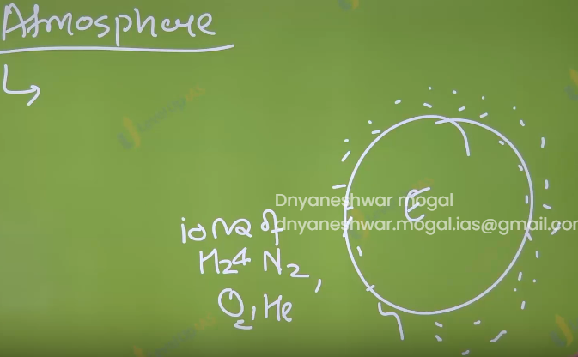

Composition of atmosphere:

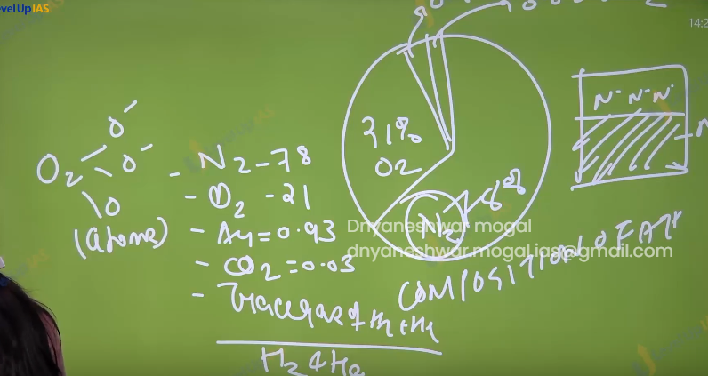

Element of climent.

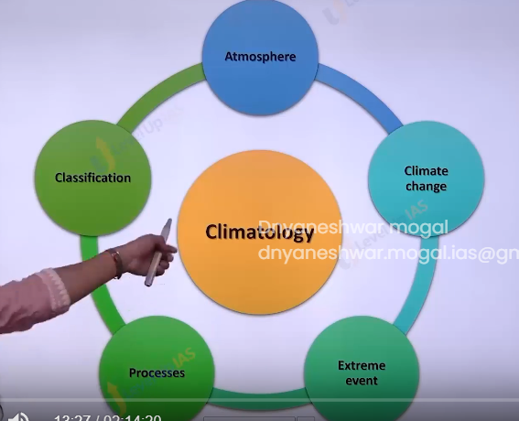

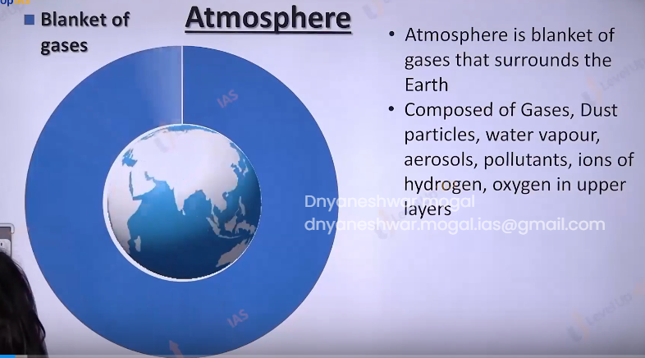

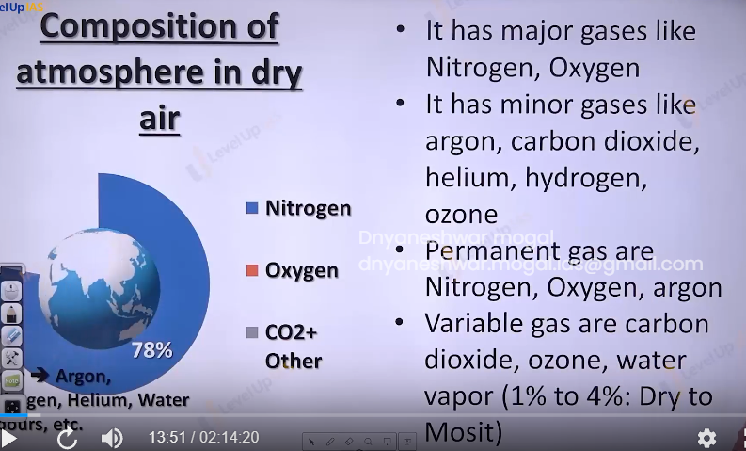

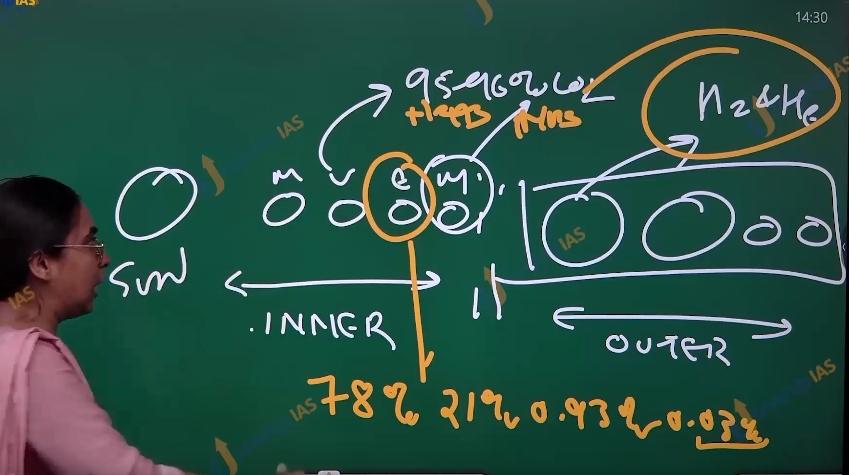

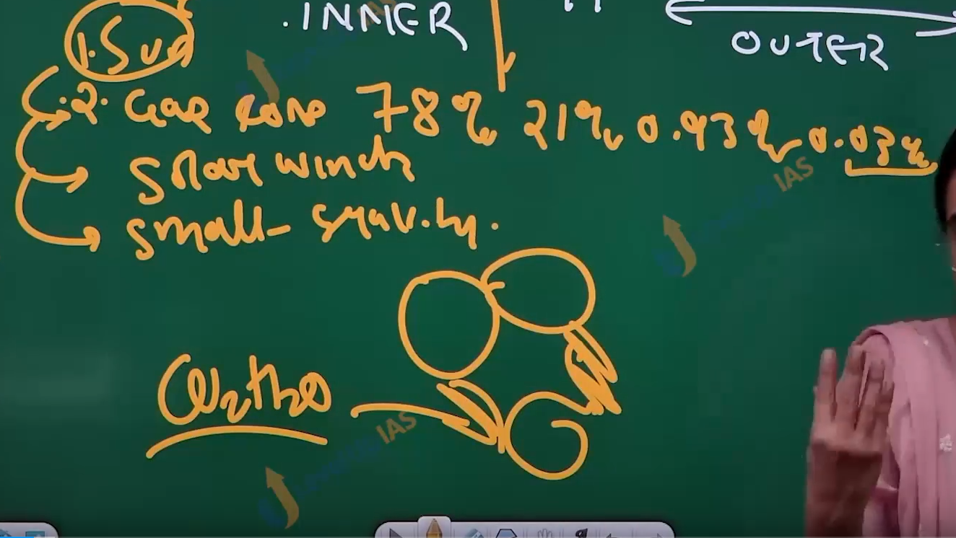

1. For most inner planets hydrogen and helium remain in the gases form due to high temperature. And continuous event of solar flare blows the gas away to outer planet.
2. Earth is at a suitable distance here carbon dioxide get the chance to settle down in the ocean and from co2h2o also called carbonic acid.

Phases of evolution of atmosphere:

1. Earth been the hot nebula with pre mordial atmosphere composed of hydrogen and helium
2. Loss of pre mordial atmosphere because of effect of solar wind.
3. The degassing stage. And the release of carbon dioxide, water vapour and ammonia
4. The cycle of evaporation cooling of water vapor condensation and precipitation in this process the water droplet the dissolve the co2 which accumulates in form of ocean water.
5. Ammonia strikes by the UV rays to split into nitrogen and hydrogen.
6. Hydrogen gas evaporates and nitrogen continues to build up.
7. Stage of formation of oxygen; in the ocean with the formation of life like cyno bacteria co2 is utilized and the oxygen is released as by product once the ocean water is saturated as a biproduct oxygen becomes the part of atmosphere.

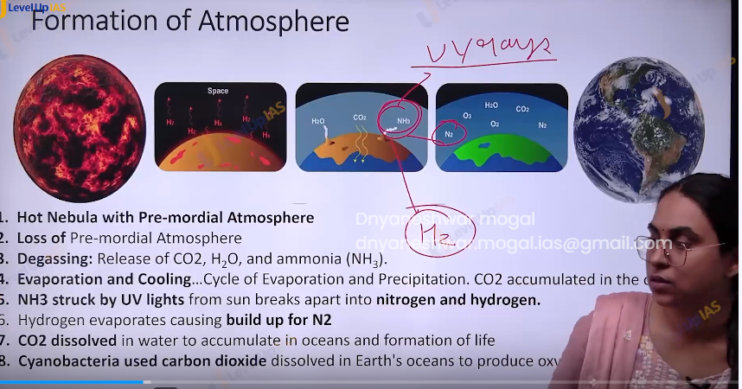

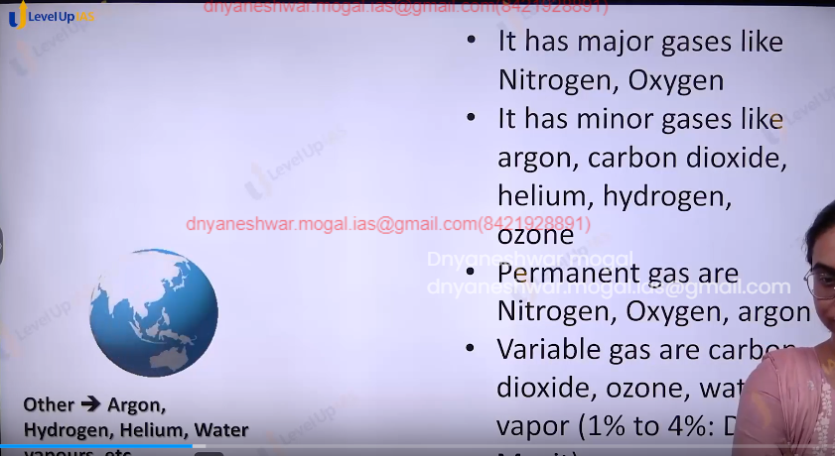

1. Nitrogen oxygen and argon do not directly play a important role in various climatic processes like wind rain fall as they are not greenhouse gases.
2. Green house gases are those that observe the heat ex, methane, Co2 ozone. Etc.
3. Layer of atmosphere based the changes in the temperature.

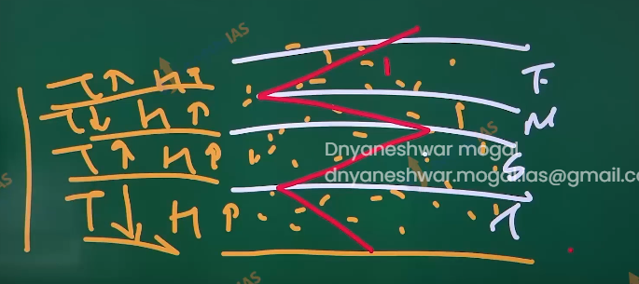

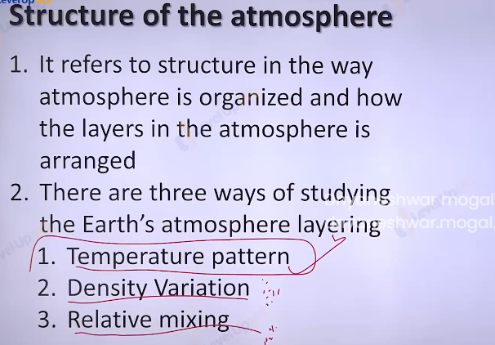

Layering of the atmosphere:

It refers to structure in the way atmosphere is organized how the layer are arranged. There can be 3 ways of layering

On the basis of temperature pattern.

On the basis of relative mixing

On the basis of density variation.

Atmospheric layering on the basis of density variation.

1. Atmosphere has weight and it is compressible. Nealy 50% of atmosphere within 5.6 km.
2. 90 % within the 16km
3. 99% atmosphere are within the 30km.

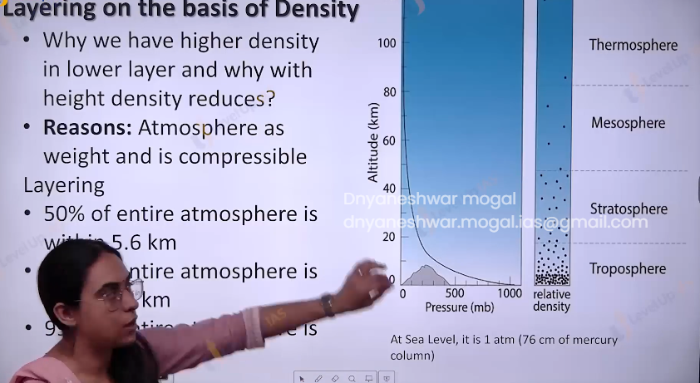

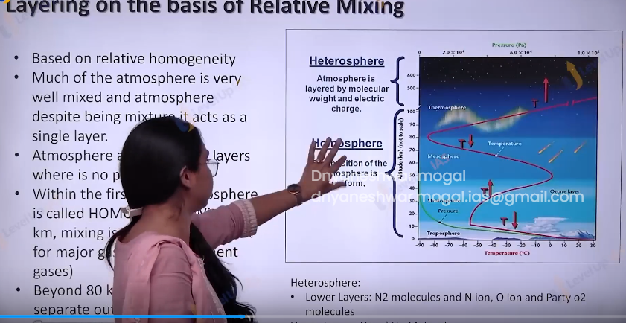

Layering on the basis of relative mixing:

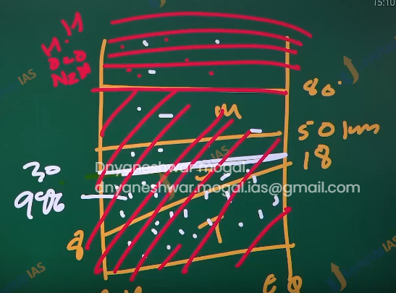

1. Much of the atmosphere is very well mixed despite being the mixture of gases it act as one single layer of gas. This is seen in the first 80 km it is called in homosphere.
2. Above 80 km the gases and iron are separated out on the basis of their weight. This is called as hetrosphere.
3. The lower layer have the nitrogen molecules and nitrogen iron along with oxygen ions and oxygen molecules while upper layers have hydrogen and helium molecules.
4. Layer on the basis of temperature pattern.
5. The layers are troposphere, stratosphere, mesosphere, thermosphere, exosphere.
6. The temperature reduces with increasing in height in troposphere, increasing in stratosphere, reduces in the mesosphere, increases in thermosphere& exosphere.

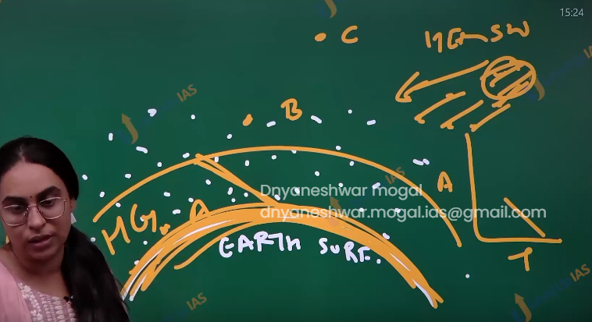

Heating mechanisms in the atmosphere.

1. Atmosphere that surrounds the earth surface is heated in the two ways
2. observation of the UV rays by the ozone layer in troposphere
3. observation of the long wave radiation from the earth surface by the greenhouse gases. (long wave terrestrial radiation infra ray radiation)
4. Gamma x ultra visible infra micro radio.
5. Greenhouse gases are transparent to incoming solar radiation but are opeck the outgoing terrestrial radiation. The lower atmosphere heated to process of conduction (transfer of heat) convection (lower surface heated first it will move to upper) and advection (heat is travelling horizontally heatwave).

Green house gases

1. Carben dioxide
2. Methane
3. Nitrogen
4. Nitrous oxide
5. Hydrofluorocarbons
6. Perfluorocarbon
7. Sulfur hexafluoride
8. Nitrogen trifluoride.
9. Ozone
10. HCFC.

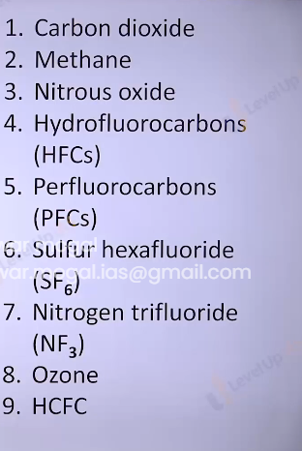

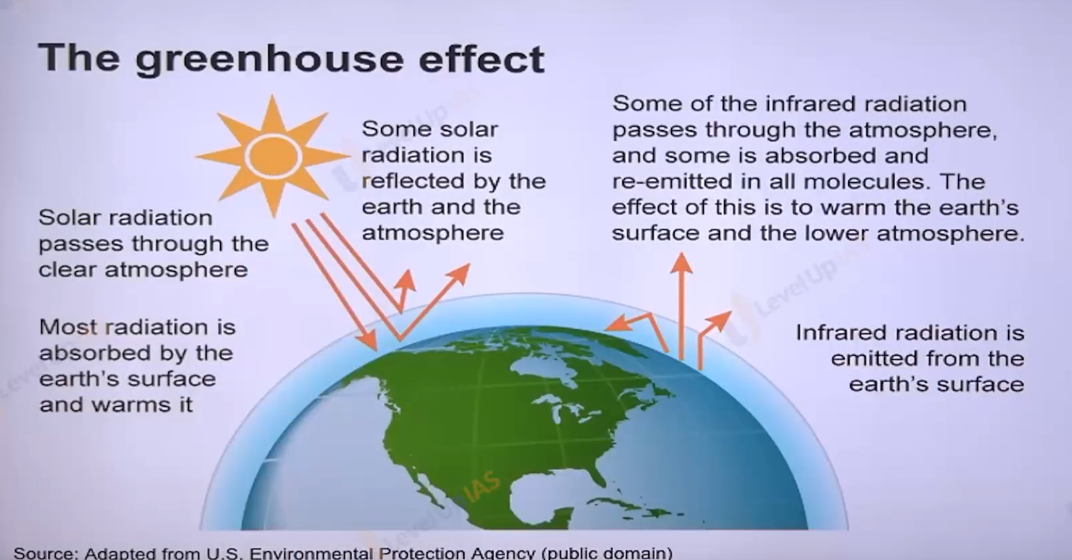

Q. which of the following is correct.

1. The amount of insulation received at the equator is roughly 10 time more than pole.
2. Infrared radiation constitutes 2/3 rd of the insulation.
3. Infrared radiation is largely observed by the water vapor that is concentrated at the lower atmosphere.
4. infrared radiations are part of visible spectrum of electromagnetic radiation

The answer is 3. Because UVI Ultra and visible spectrum contains 63 percent and infrared contains 37 percent not approx. 1/3 b is wrong

the insulation is more at the equator but not 10 times.

Layer of atmosphere on the basis of temperature pattern.

Troposphere.

1. The temperature reduces with the increase in the height as troposphere is heated from the below out going long wave terrestrial radiation.
2. The rate of cooling is 1-degree Celsius per 165 m or 6.4 degrees Celsius per km this is called as normal lapse rate
3. The height of troposphere is 8 km at pole and 18 km at the equator, the average height is 13 km.
4. Thickness is greater at the equator because heat is transported to greater height by the conventional air currents, the air packet rises up to great height before it starts turning away. Troposphere word is derived from troop which means turning away.
5. The troposphere is also called convective reason, since all the convection is stop at tropopause.
6. 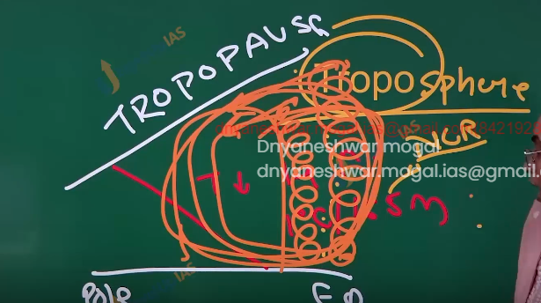
7. A
8. Troposphere experience fall in temperature the temperature Is -80 degrees Celsius at the equator at the tropopause. While at pole temperature is -45 degree Celsius at the tropopause.
9. 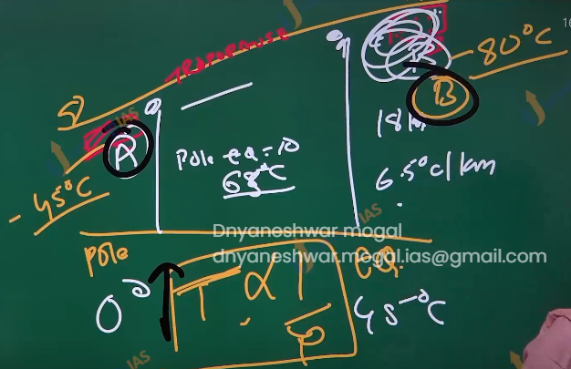
10. A
11. Meteorologically this most significant layer as the entire atmosphere and near all the weather phenomena like cyclone, rainfall, fog, Hellstrom, are confined to this layer.
12. Above the troposphere the temperature is constant in tropopause, therefore tropopause acts as lid and holds all the circulation within the tropopause.
13. All the Jet planes and aero planes fly in the tropopause in the lower stratosphere.

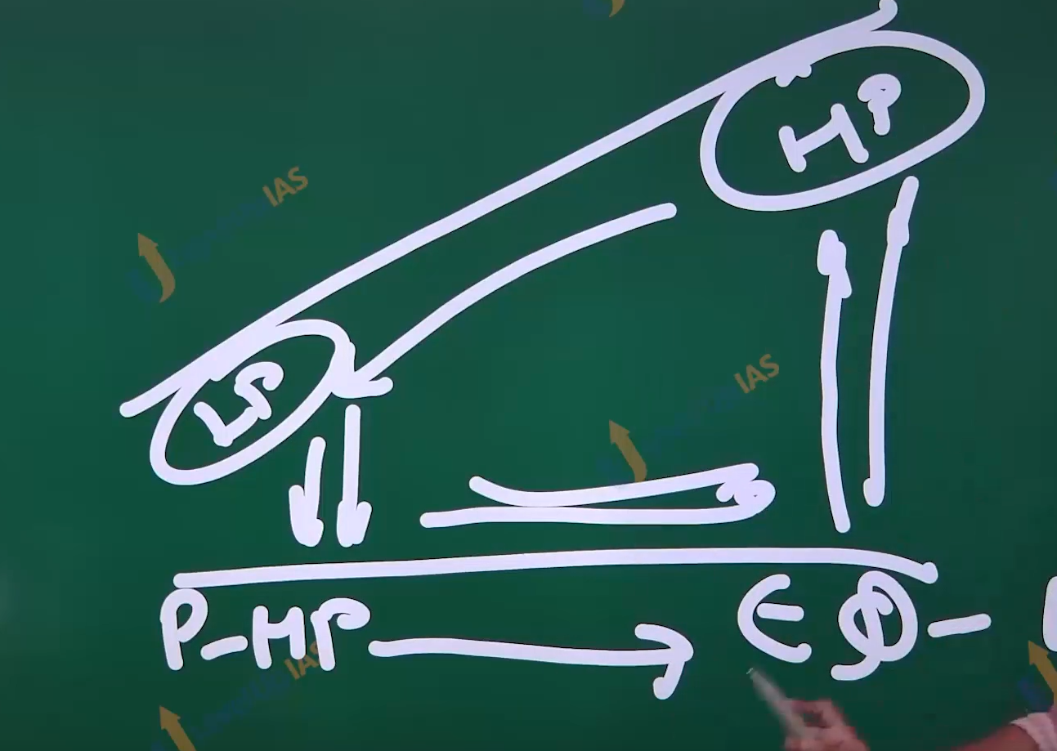

(15) Atmosphere Layering and Heat Budget

This

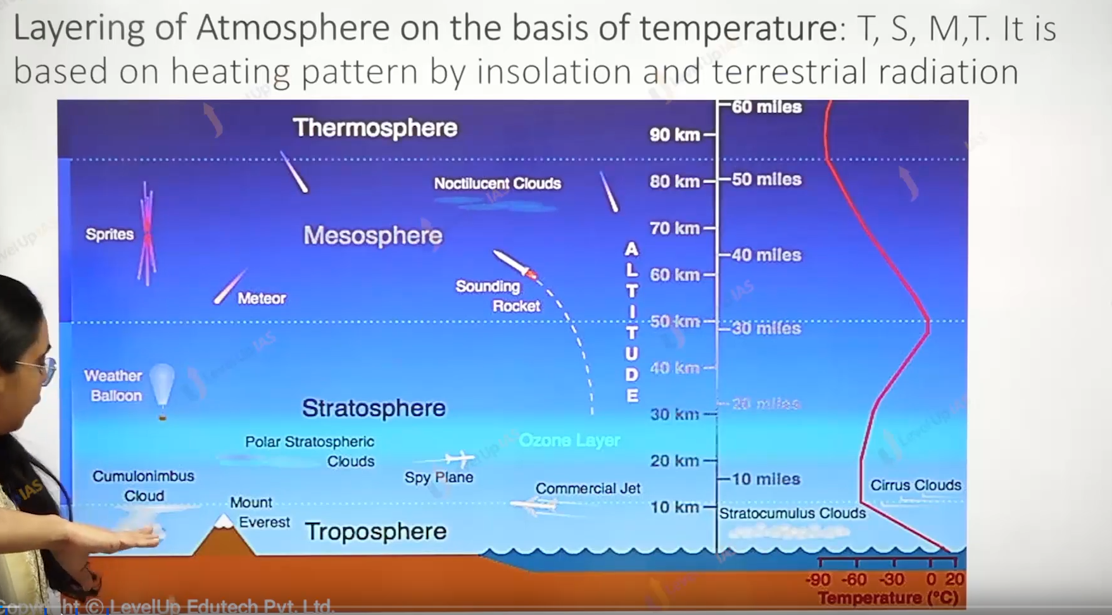

PV/T is not constant in the atmosphere PV/T is constant in the close system or close glass. In the real world pt is constant in the p is inversely proportional to temperature.

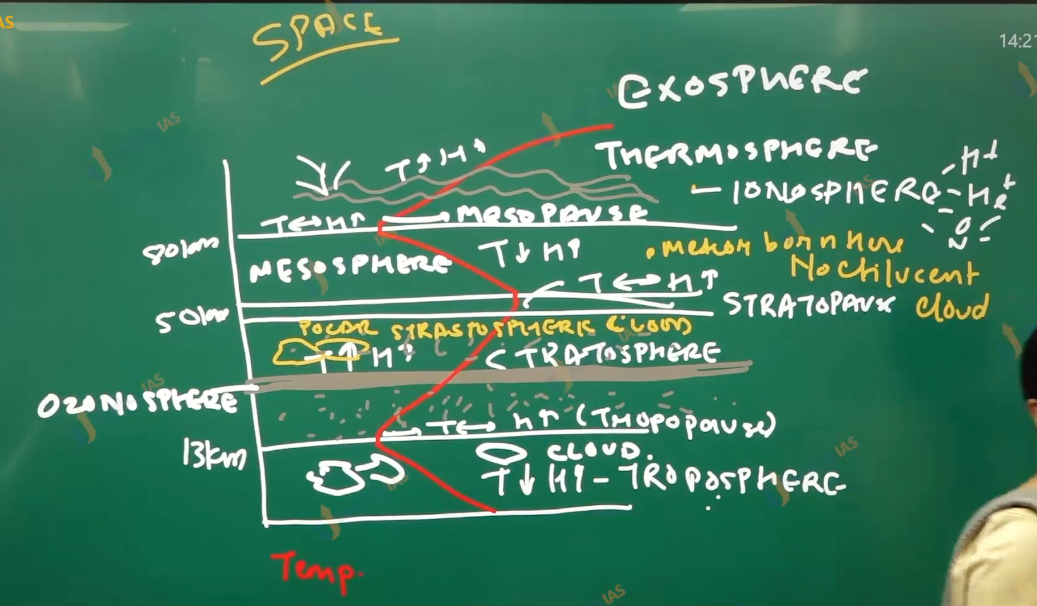

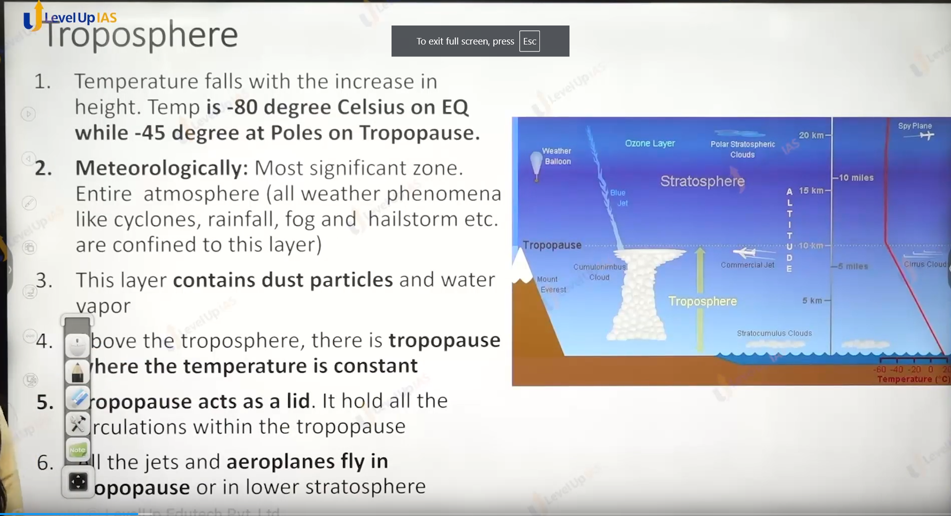



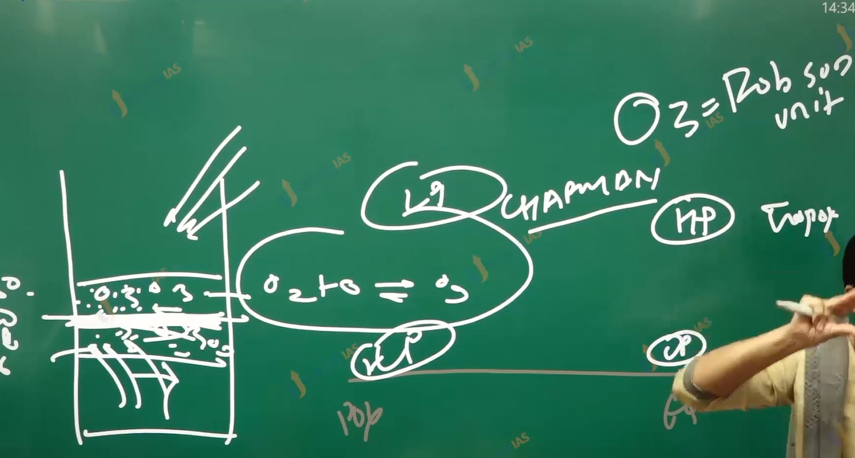

Stratosphere:

1. It is layer above the troposphere
2. Temperature increases with increase in the height
3. temperature reaches zero degree Celsius at 50 km. rise of temperature is due to present of ozone which observe infrared ray incoming and reflecting from surfaces.
4. This layer is almost free from the cloud and therefore the Aeroplan fly in this layer. (plane can also fly in the tropopause)
5. In the stratopause the temperature is constant with increasing in height.
6. Ozone molecules and Ozone gas present throughout the stratosphere that is 10 km to 50 km but there is buildup of Ozone between 20-30 km as UV rays’ tents to split the ozone molecules up from 50 km to 30 km, and the terrestrial infrared radiation split the ozone molecules from the lowest stratosphere up to 20km.

Mesosphere:

1. It lies above the stratosphere and extends up to 80km.
2. Most meteors burn in this layer on entering space. Cause friction.
3. The temperature drops with increasing altitude up to mesopause. The temperature is -45 degrees Celsius and the mesopause is the coldest layer in the atmosphere. As the air is very cold even very scarce water vapor can condense into mesospheric cloud called noctilucent cloud.

Thermosphere:

1. In this layer the temperature rises rapidly with increasing in height because of radiation from the sun. (heated from the above) its extents between 80 – 400 km. though the temperature is very high any object and person in this layer does feel the heat because the atmosphere is very rarefied that Is gas molecules are spaces 100km apar.
2. The international space station and satellites orbit in this layer. The auroras are observed in the lower part of this layer.
3. The Karman line is located at an altitude of 100 km and used to define boundary between the space and earth’s atmosphere.

Ionosphere:

1. The ultraviolet and x ray solar radiation ionizes the atom and molecules creating the layer of ions called ionosphere.
2. Ionosphere is plays important role for depleting the radio wave for communication
3. Discovery of the ionosphere was made by the author Kennelly and Oliver Heaviside who explain the transmission of radio wave signal around the curved earth surface therefore the ions rich layer also refers as Kennelly Heaviside layer.
4. Ionosphere has many layer D,E,F .
5. D is the lowest layer and it reflects the long wavelength radio wave and allows short and medium wavelength radio wave.
6. E layer reflects the medium wave radio wave and extents from 90-160 km
7. F layer reflects the short-wave radio wave and extends from 160-300 km

Exosphere:

1. From the above the 400 km atmosphere is very rarefied
2. The temperature increases with increase in height.
3. It has light gases, and it considers space.

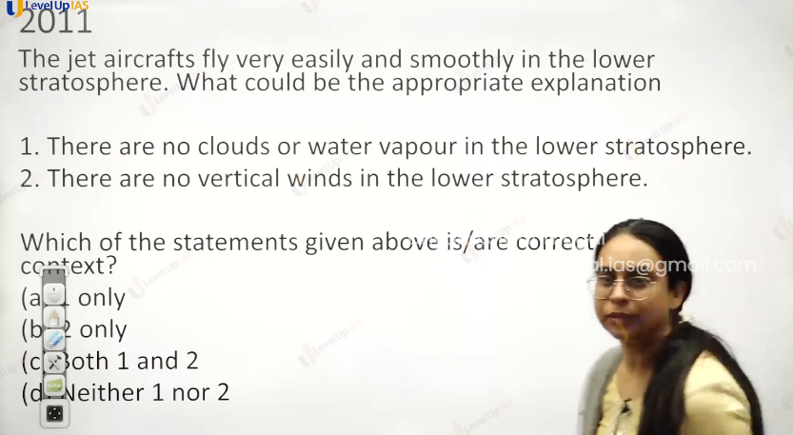

The answer is c because no clouds and water vapor less disturbance.

And in the troposphere, there is air conventional current so vertical wind meaning plane are stable and low fuel.

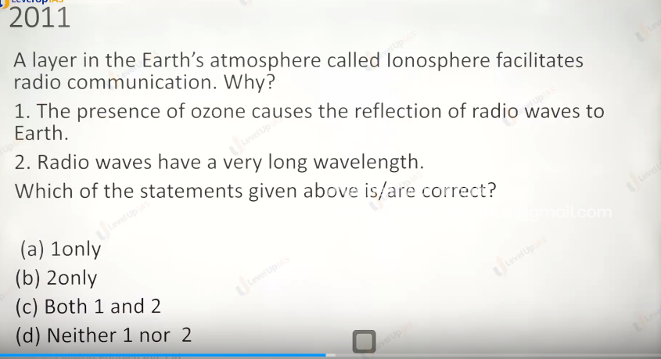

Option d

Ozone is present in the stratosphere.

For 2 short medium and long wavelength all are reflected. Cause of ions

Not because of the long wavelength of radio.

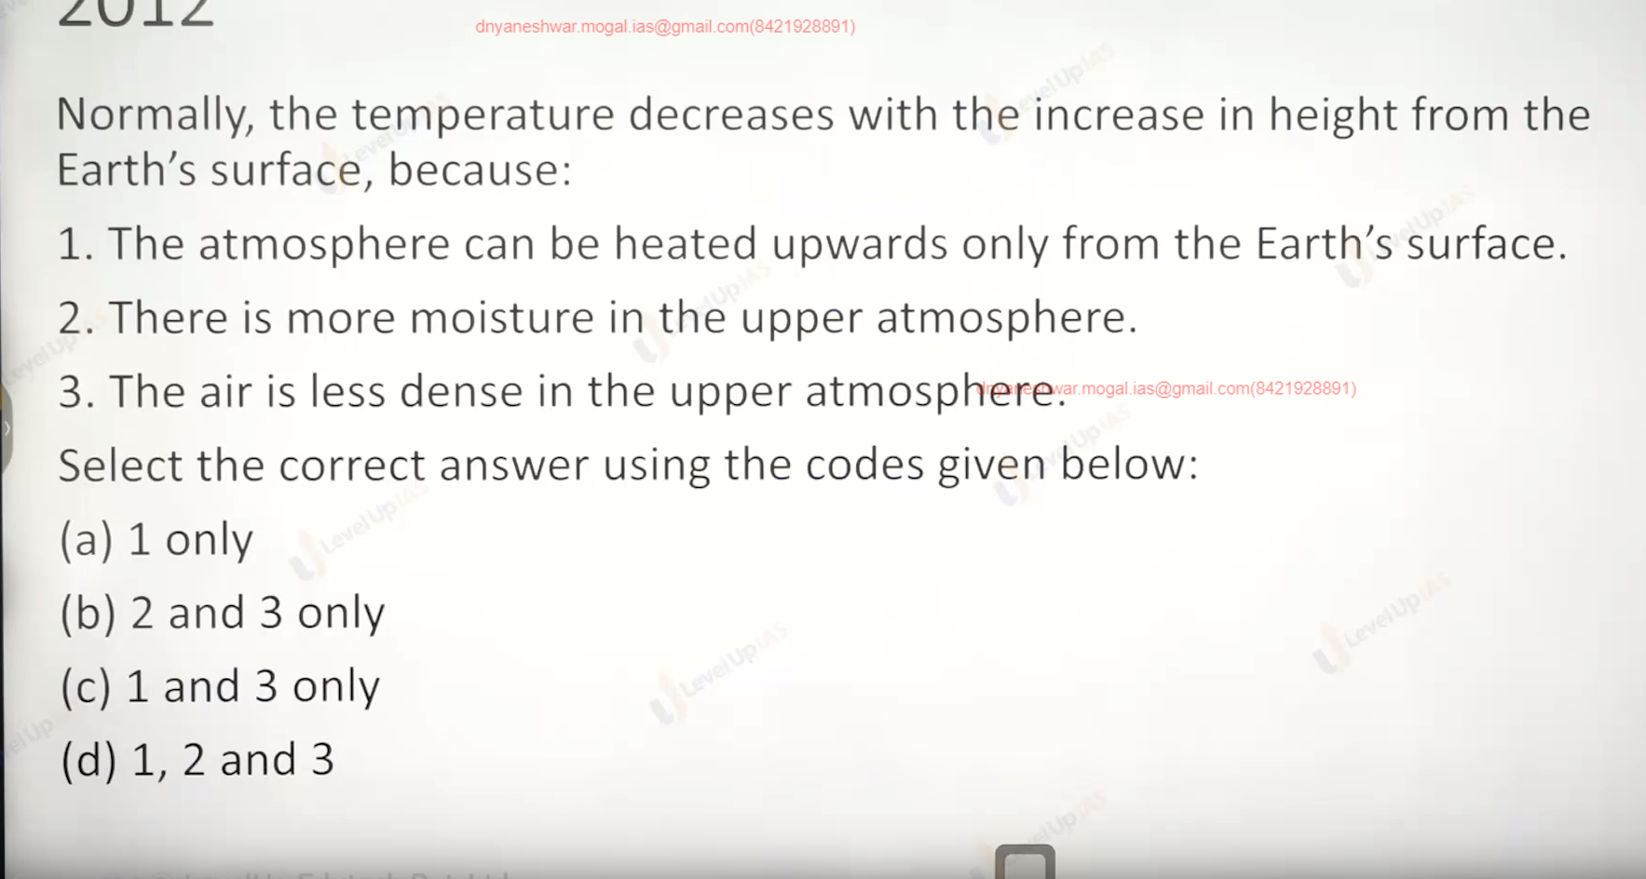

Only c.

1 is obviously true and for 3 is somewhere true less molecule’s small chance of getting heated.

2 moisture is less in the upper atmosphere as height increases.

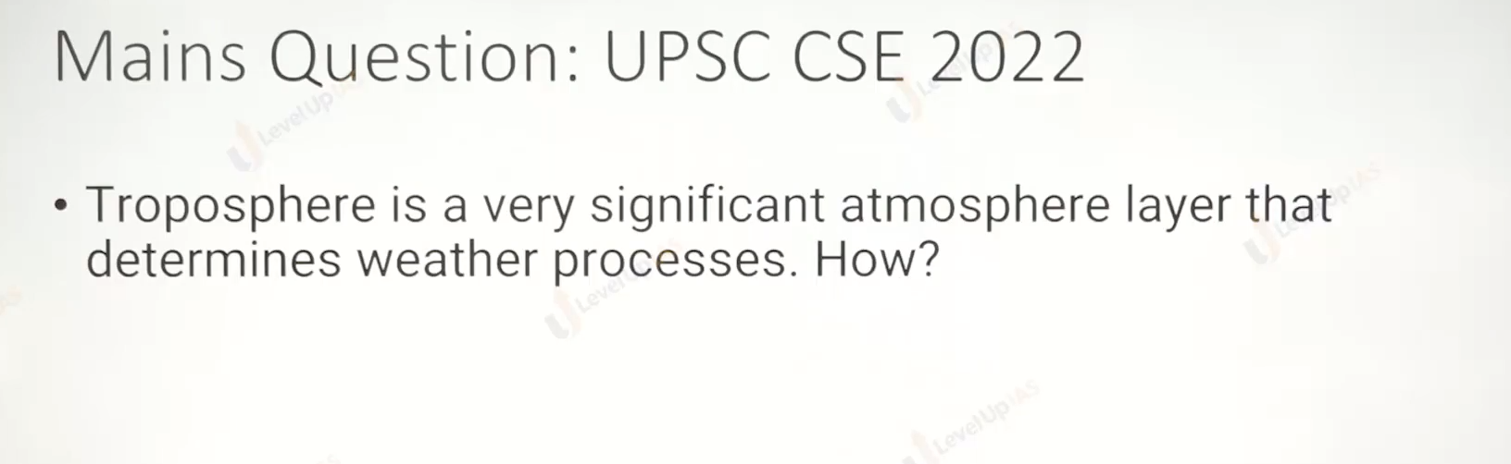

Temperature 🡪 pressure🡪 winds 1.

Climate : Heat budget , temperature pattern.

Heat budget.

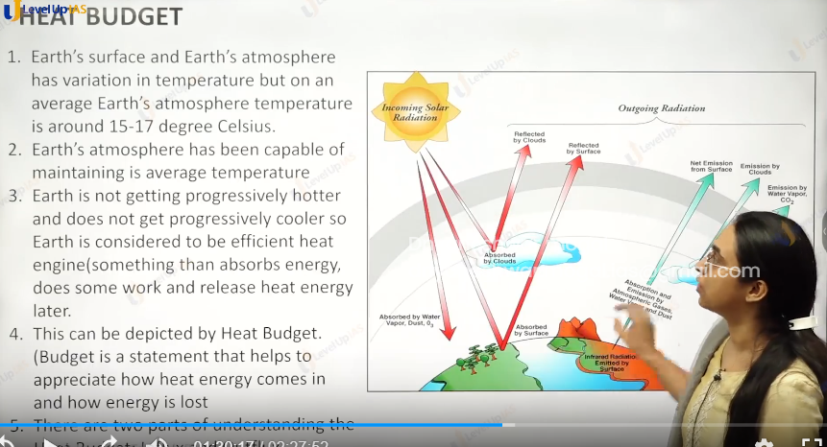

1. The earth’s surface and the earth’s atmosphere has variation in the temperature but on an average the earth’s atmospheric temperature 15 to 17 degrees Celsius.
2. Earth’s atmosphere has been capable of maintaining the average temperature i.e. earth is not getting progressively warmer and progressively cooler. So, the earth Is efficient heat engine. This maintenance of temperature can be defected by the heat budget.
3. Budget is a statement where it can be appreciated how energy comes and how the energy goes.
4. There are two components to heat budget
   1. Incoming solar radiation and outgoing radiation.



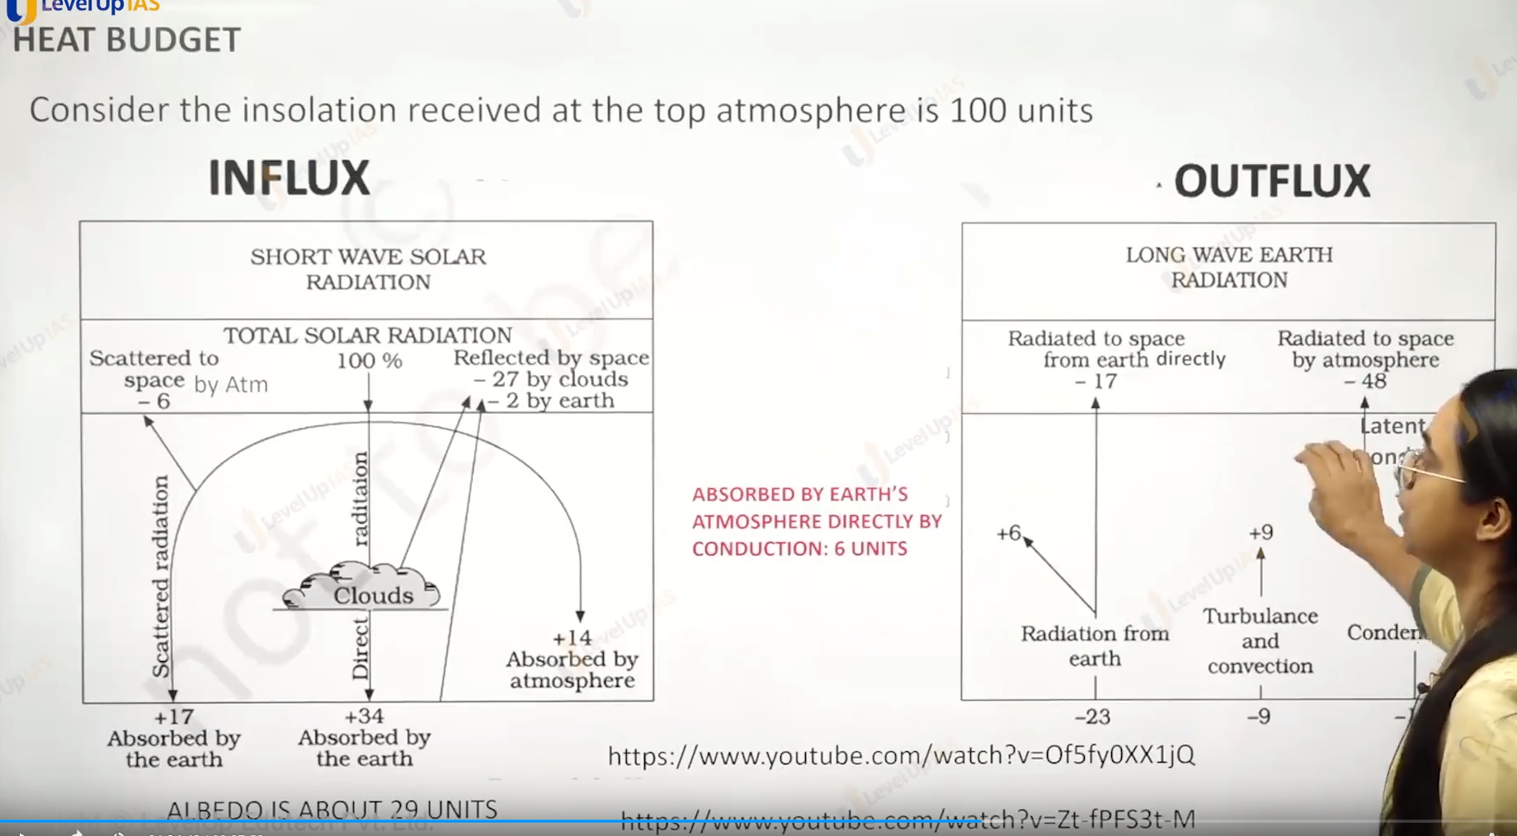

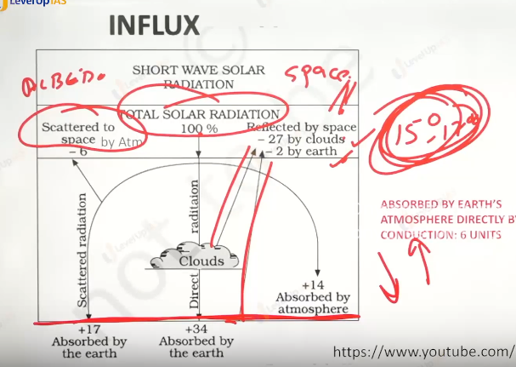

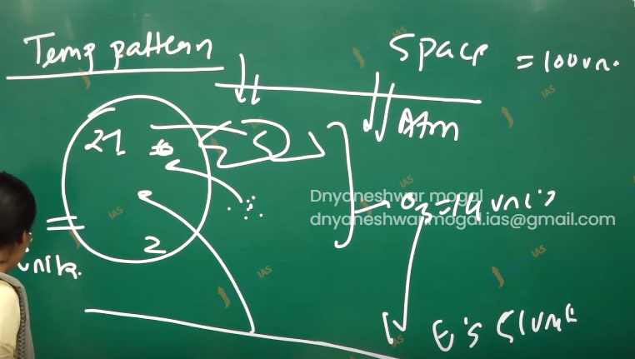

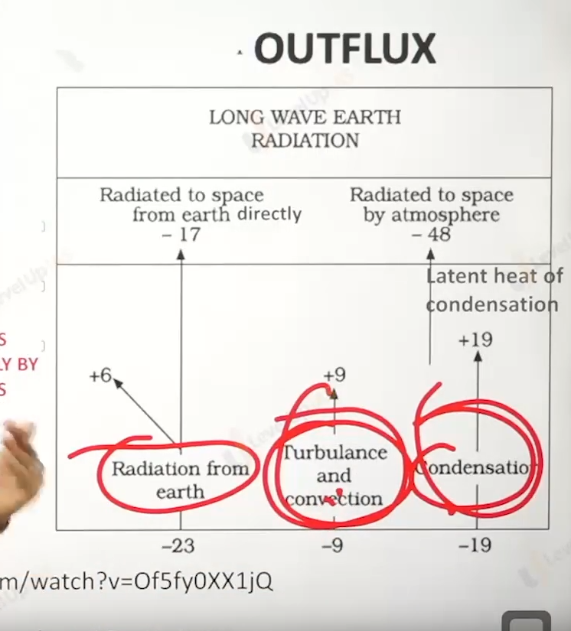

Influx component:

1. In flux 100 units are received from the solar radiation nearly 35% reflected (albedo reflectivity) 27% from the cloud 2 by the earth surface and 6 from the atmosphere.
2. 14 unit is observed by the ozone. And 51 units are observed by the earth’s surface.

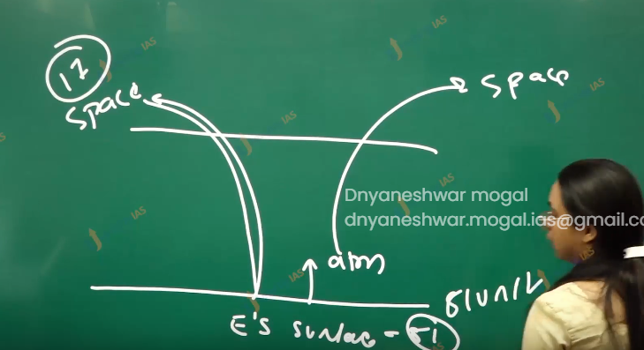

Outflux component.

1. 17 units are radiated from the earth’s surface directly to space.
2. The earth's surface transfer heat via radiation convection and condensation.
3. Surface to earth's atmosphere radiation losses is 6 units.
4. Turbulence and convection transfer are 9 units.
5. From earth’s surface to earth's atmosphere condensation related transfer are 19 unit
6. The units received by the atmosphere is 9+19+6 =34 Units.
7. Atmosphere sends 34 units to space. The 14 units observed by the ozone layer are sent to space by does completing the heat budget.

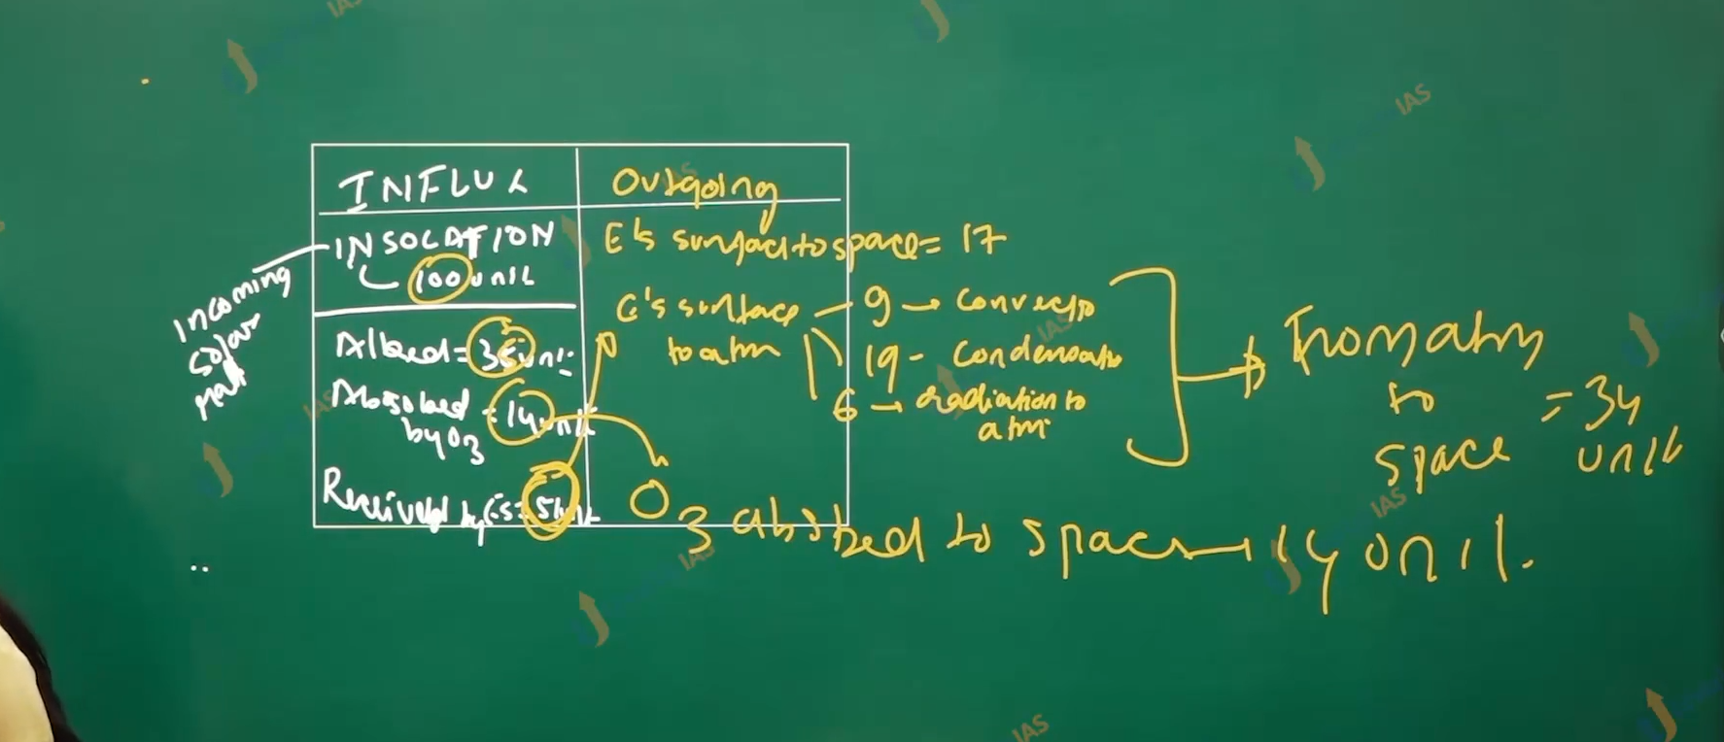

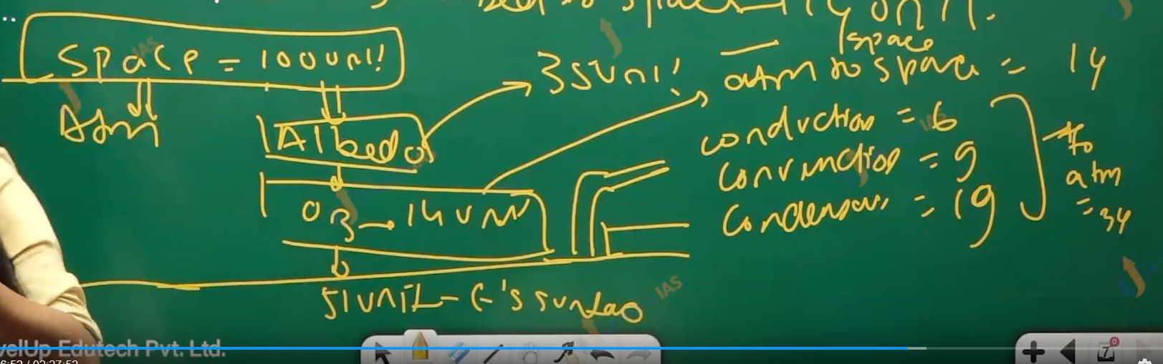



Heat budget :

1. heat receive is not lost instantaneously, the energy receive is observed and work is done, in formed of biological and other physical processes this manifest in the form of climate and weather conditions.
2. Despite the earth atmosphere in the being balance there are places which are net receiver of energy, and there are places where energy is deficits.
3. The low latitude are latitudes of energy surplus while high latitude are energy deficits.
4. The internal latitudinal exchanges drives the atmosphere and ocean waterflow.

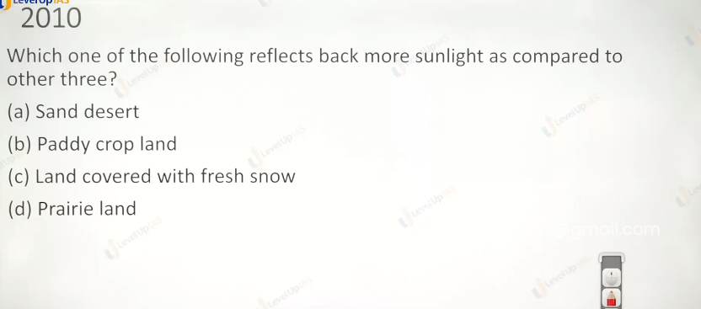

C

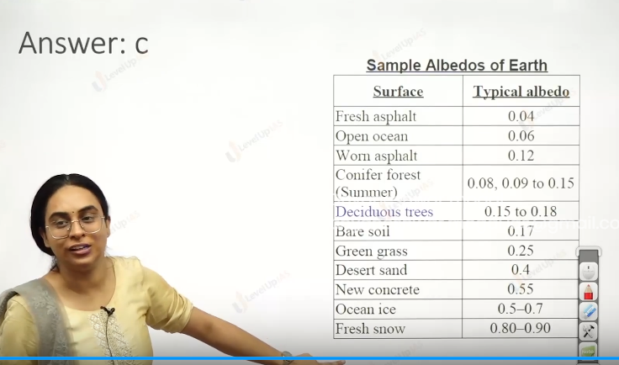

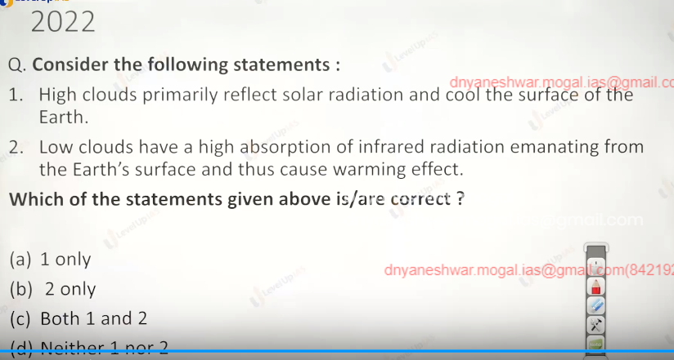

D. low cloud are thicker enough to reflect the more and it is white.so lower cloud reflect the more heat that high cloud.

And high cloud will observer more (don’t know.)

Role of cloud in warming and cooling the earth.

1. The low clouds primarily reflect the solar radiation and cool the surface of the earth.
2. High cloud observes the infrared the from the earth surface and thus have warming the planet.

